Mushiny WMS Inbound

目录

1 Receiving Destination 3

1.1 List 3

1.2 Create 5

1.3 Detail 7

1.4 Edit 8

1.5 Delete 10

2 Receiving Working Station Type 12

2.1 List 12

2.2 Create 14

2.3 Edit 17

2.4 Detail 20

2.5 Delete 22

3 Receiving Working Station 24

3.1 List 24

3.2 Create 26

3.3 Edit 28

3.4 Detail 30

3.5 Delete 32

4 Rule Setting【延迟】 34

4.1 List 34

4.2 Create 34

4.3 Detail 35

4.4 Edit 36

5 Filter Basic Information 38

5.1 List 38

5.2 Create 39

5.3 Detail 40

5.4 Edit 41

6 Advice [DN] 42

6.1 Advice List 42

6.2 Create 43

6.3 Detail 46

6.4 Delete 47

7 Goods Receipt 49

7.1 List 49

7.2 Activated 50

7.3 Detail 52

8 Receiving [Each] 54

8.1 主页面 54

8.2 Receiving准备 55

8.3 Receiving正常作业 57

8.4 有效期检查 60

8.5 测量商品 62

8.6 登记残品 64

8.7 货款已满 66

9 Receiving [Pallet] 68

9.1 Receiving准备 68

9.2 Receiving作业【自动满框】 68

9.3 Receiving作业【手动满框页面】 73

9.4 Receiving作业【货框已满】 75

10 Stow Operation[上架] 77

10.1 上架作业步骤 77

10.2 单件上架 78

10.3 批量上架 79

10.4 残品处理 80

10.5 多货处理 81

10.6 信息查询 82

10.7 报告暗灯【暂定】 83

10.8 结束上架 84

# Receiving Destination

## List

1. List页面
2. 功能： 显示所有Receiving Destination记录

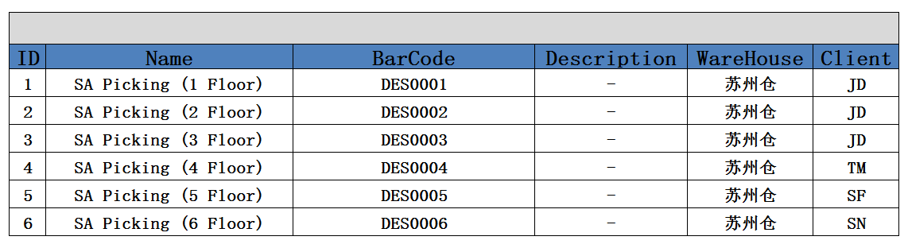

1. 方法：

|  |
| --- |
| GET /System/ receivingdestination |

1. 示例：

|  |
| --- |
| {  " receivingdestination_search response ": {  " receivingdestination_List": [  {  "id": " 903747BB-57CF-4272-8582-E30E61D67DBC",  "ClientId": {  "id": " 903747BB-57CF-4272-8582-E30E61D67DBC",  "name": "京东"  },  "WarehouseId": {  "id": " 903747BB-57CF-4272-8582-E30E61D67DBC",  "name": "苏州仓"  },  "destinationType": {  "id": " 903747BB-57CF-4272-8582-E30E61D67DBC",  "name": "Receiving Destination"  },  "name": " JD_WS0001",  "Description": " - ",  "  "VERSION" : 1,  "ENTITY_LOCK":"100",  “CREATED_BY”: {  “id”: “0123456789abcdef0123456789abcdef”,  “username”: “admin”  },  “MODIFIED_BY”: {  “id”: “0123456789abcdef0123456789abcdef”,  “username”: “admin”  },  “MODIFIED_DATE”: “2012-01-01T12:00:00Z”,  “MODIFIED_ DATE”: “2012-01-01T12:00:00Z”  }  ],  "total": 1,  }  } |

## Create

1. Create页面
2. 功能： 创建一条Destination记录

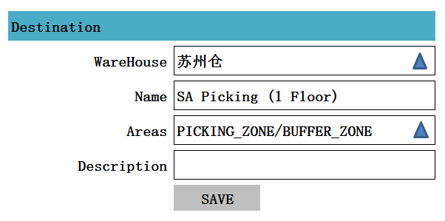

注释： 追加一个Areas字段

1. 方法：

|  |
| --- |
| POST /System/ receivingdestination |

1. 输入参数

|  |  |  |  |  |
| --- | --- | --- | --- | --- |
| **参数名称** | **类型** | **是否必须** | **示例值** | **描述** |
| WareHouse_NO | String | 是 | 苏州仓 | 仓库编码 |
| Client_NO | String | 是 | JD | 客户编码 |
| Name | String | 是 | RD0001 | Destination location 名称 |
| Description | String | 否 | 描述信息 |  |

1. 示例：

|  |
| --- |
| {  "id": " 903747BB-57CF-4272-8582-E30E61D67DBC",  "ClientId": {  "id": " 903747BB-57CF-4272-8582-E30E61D67DBC",  "name": "京东"  },  "WarehouseId": {  "id": " 903747BB-57CF-4272-8582-E30E61D67DBC",  "name": "苏州仓"  },  "name": " RD0001",  "Description": " - ",  "  "VERSION" : 1,  "ENTITY_LOCK":"100",  “CREATED_BY”: {  “id”: “0123456789abcdef0123456789abcdef”,  “username”: “admin”  },  “MODIFIED_BY”: {  “id”: “0123456789abcdef0123456789abcdef”,  “username”: “admin”  },  “MODIFIED_DATE”: “2012-01-01T12:00:00Z”,  “MODIFIED_ DATE”: “2012-01-01T12:00:00Z”  } |

## Detail

1. Detail页面

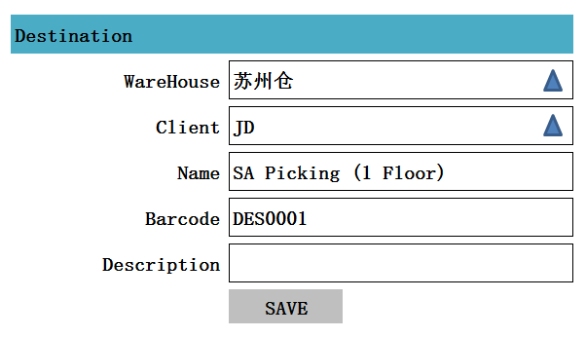

1. 功能：获得一条receivingdestination记录
2. 方法：

|  |
| --- |
| GET /System/ receivingdestination /{id} |

4、示例：

|  |
| --- |
| {  "id": " 903747BB-57CF-4272-8582-E30E61D67DBC",  "ClientId": {  "id": " 903747BB-57CF-4272-8582-E30E61D67DBC",  "name": "京东"  },  "WarehouseId": {  "id": " 903747BB-57CF-4272-8582-E30E61D67DBC",  "name": "苏州仓"  },  "name": " RD0001",  "Description": " - ",  "  } |

## Edit

1. Edit页面



1. 功能：编辑一条receiving destination记录
2. 方法：

|  |
| --- |
| PUT /System/ receivingdestination /{id} |

1. 输入参数

|  |  |  |  |  |
| --- | --- | --- | --- | --- |
| **参数名称** | **类型** | **是否必须** | **示例值** | **描述** |
| WareHouse_NO | String | 是 | 苏州仓 | 仓库编码 |
| Client_NO | String | 是 | JD | 客户编码 |
| Name | String | 是 | RD0001 | Destination location 名称 |
| Description | String | 否 | 描述信息 |  |

1. 示例：

|  |
| --- |
| {  "id": " 903747BB-57CF-4272-8582-E30E61D67DBC",  "ClientId": {  "id": " 903747BB-57CF-4272-8582-E30E61D67DBC",  "name": "京东"  },  "WarehouseId": {  "id": " 903747BB-57CF-4272-8582-E30E61D67DBC",  "name": "苏州仓"  },  "name": " RD0001",  "Description": " - ",  "  "VERSION" : VERSION + 1,  "ENTITY_LOCK":"100",  “CREATED_BY”: {  “id”: “0123456789abcdef0123456789abcdef”,  “username”: “admin”  },  “MODIFIED_BY”: {  “id”: “0123456789abcdef0123456789abcdef”,  “username”: “admin”  },  “MODIFIED_DATE”: “2012-01-01T12:00:00Z”,  “MODIFIED_ DATE”: “2012-01-01T12:00:00Z”  } |

## Delete

1. 功能： 删除一条receivingdestination记录

2、方法：

|  |
| --- |
| DELETE /System/ receivingdestination /{id} |

1. 示例

|  |
| --- |
| {  "id": " 903747BB-57CF-4272-8582-E30E61D67DBC",  "ClientId": {  "id": " 903747BB-57CF-4272-8582-E30E61D67DBC",  "name": "京东"  },  "WarehouseId": {  "id": " 903747BB-57CF-4272-8582-E30E61D67DBC",  "name": "苏州仓"  },  "name": " RD0001",  "Description": " - ",  "  "VERSION" : VERSION + 1,  "ENTITY_LOCK":"101",  “CREATED_BY”: {  “id”: “0123456789abcdef0123456789abcdef”,  “username”: “admin”  },  “MODIFIED_BY”: {  “id”: “0123456789abcdef0123456789abcdef”,  “username”: “admin”  },  “MODIFIED_DATE”: “2012-01-01T12:00:00Z”,  “MODIFIED_ DATE”: “2012-01-01T12:00:00Z”  } |

# Receiving Working Station Type

## List

1、页面

1. 功能：显示所有Receiving Station Type 记录

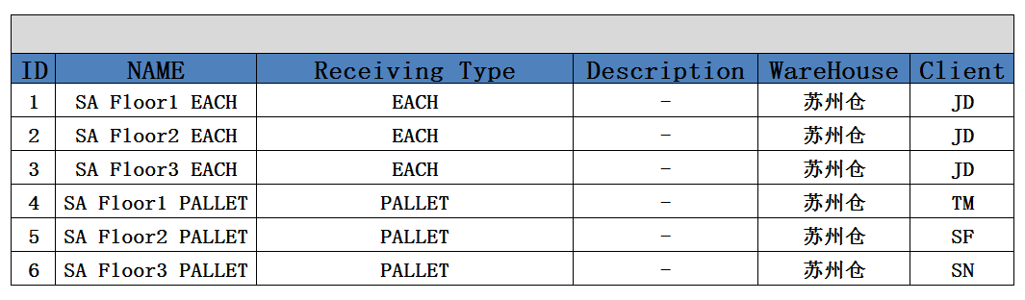

1. 方法：

|  |
| --- |
| GET /System/ ReceivingStationType |

4、示例：无

|  |
| --- |
| {  " ReceivingWorkingStationType _search response ": {  " ReceivingWorkingStationType _List": [  {  "id": " 903747BB-57CF-4272-8582-E30E61D67DBC",  "ClientId": {  "id": " 903747BB-57CF-4272-8582-E30E61D67DBC",  "name": "京东"  },  "WarehouseId": {  "id": " 903747BB-57CF-4272-8582-E30E61D67DBC",  "name": "苏州仓"  },  "name": " RD0001",  "Description": " - ",  "  "VERSION" : 1,  "ENTITY_LOCK":"100",  “CREATED_BY”: {  “id”: “0123456789abcdef0123456789abcdef”,  “username”: “admin”  },  “MODIFIED_BY”: {  “id”: “0123456789abcdef0123456789abcdef”,  “username”: “admin”  },  “MODIFIED_DATE”: “2012-01-01T12:00:00Z”,  “MODIFIED_ DATE”: “2012-01-01T12:00:00Z”  }  ],  "total": 1,  }  } |

## Create

1. 页面

2、功能1：新建一条Receiving Station Type 记录

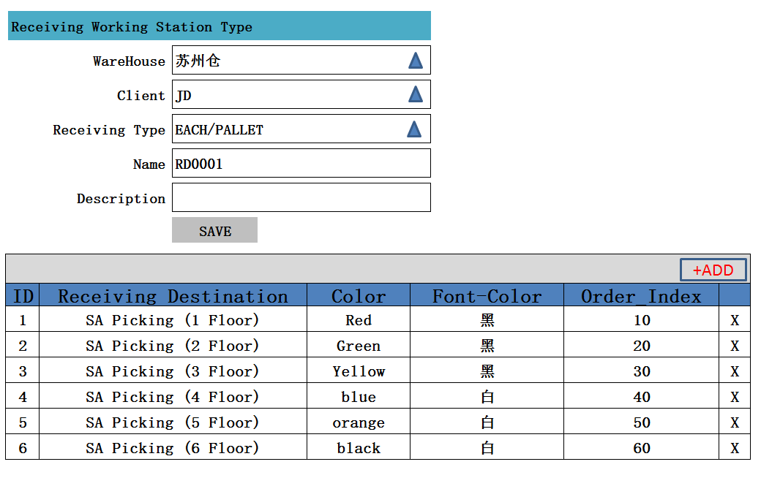

3、方法1：

|  |
| --- |
| POST /System/ ReceivingStationType |

4、示例：无

|  |
| --- |
| {  " ReceivingWorkingStationType _search response ": {  " ReceivingWorkingStationType _List": [  {  "id": " 903747BB-57CF-4272-8582-E30E61D67DBC",  "ClientId": {  "id": " 903747BB-57CF-4272-8582-E30E61D67DBC",  "name": "京东"  },  "WarehouseId": {  "id": " 903747BB-57CF-4272-8582-E30E61D67DBC",  "name": "苏州仓"  },  "name": " RD0001",  "Description": " - ",  "  "VERSION" : 1,  "ENTITY_LOCK":"100",  “CREATED_BY”: {  “id”: “0123456789abcdef0123456789abcdef”,  “username”: “admin”  },  “MODIFIED_BY”: {  “id”: “0123456789abcdef0123456789abcdef”,  “username”: “admin”  },  “MODIFIED_DATE”: “2012-01-01T12:00:00Z”,  “MODIFIED_ DATE”: “2012-01-01T12:00:00Z”  }  ],  "total": 1,  }  } |

6、ADD弹出页面

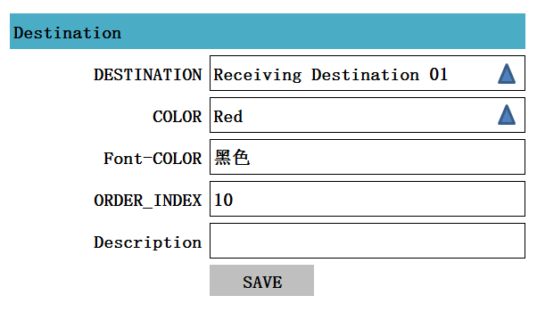

5、功能2：创建一条与Receiving Working Station Type关联的Type Destination Constraint

6、方法2：

|  |
| --- |
| POST /System/ TypeDestinationConstraint |

7、示例

|  |
| --- |
| {  "id": " 903747BB-57CF-4272-8582-E30E61D67DBC",  "name": " RD0001",  "RECEIVINGWORKINGSTATIONTYPE_ID":{  “id”: “0123456789abcdef0123456789abcdef”,  “username”: “RD0001”  },  "RECEIVINGDESTINATION_ID":{  “id”: “0123456789abcdef0123456789abcdef”,  “name”: “SA Picking (2 Floor)”  },  "COLOR":{  “id”: “0123456789abcdef0123456789abcdef”,  “name”: “Red”  },  "ORDER_INDEX" : 10,  "Description": " - ",  "VERSION" : 1,  "ENTITY_LOCK":"100",  “CREATED_BY”: {  “id”: “0123456789abcdef0123456789abcdef”,  “username”: “admin”  },  “MODIFIED_BY”: {  “id”: “0123456789abcdef0123456789abcdef”,  “username”: “admin”  },  “MODIFIED_DATE”: “2012-01-01T12:00:00Z”,  “MODIFIED_ DATE”: “2012-01-01T12:00:00Z”  } |

## Edit

1、页面

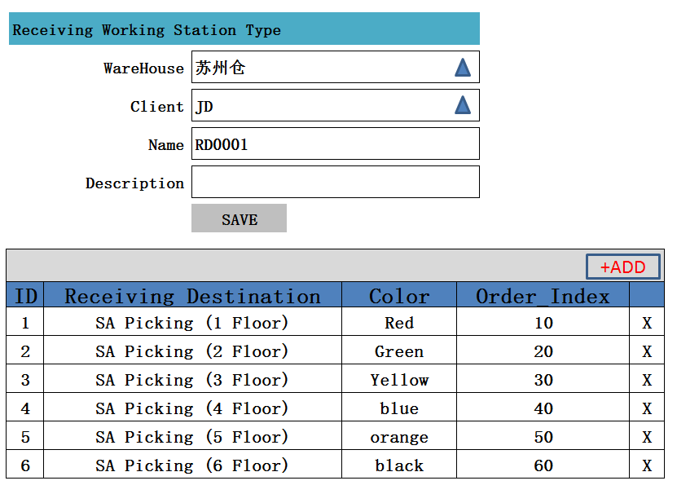

2、功能1：编辑一条Receiving Working Station Type 记录

3、方法1：

|  |
| --- |
| PUT /System/ ReceivingWorkingStationType/{id} |

1. 示例：

|  |
| --- |
| {  " ReceivingWorkingStationType _search response ": {  " ReceivingWorkingStationType _List": [  {  "id": " 903747BB-57CF-4272-8582-E30E61D67DBC",  "ClientId": {  "id": " 903747BB-57CF-4272-8582-E30E61D67DBC",  "name": "京东"  },  "WarehouseId": {  "id": " 903747BB-57CF-4272-8582-E30E61D67DBC",  "name": "苏州仓"  },  "name": " RD0001",  "Description": " - ",  "  "VERSION" : 1,  "ENTITY_LOCK":"100",  “CREATED_BY”: {  “id”: “0123456789abcdef0123456789abcdef”,  “username”: “admin”  },  “MODIFIED_BY”: {  “id”: “0123456789abcdef0123456789abcdef”,  “username”: “admin”  },  “MODIFIED_DATE”: “2012-01-01T12:00:00Z”,  “MODIFIED_ DATE”: “2012-01-01T12:00:00Z”  }  ],  "total": 1,  }  } |

5、功能2：创建一条与Receiving Working Station Type关联的Type Destination Constraint

6、方法2：

|  |
| --- |
| PUT /System/ TypeDestinationConstraint |

7、功能2：删除一条与Receiving Working Station Type关联的Type Destination Constraint

8、方法2：

|  |
| --- |
| Delete /System/ TypeDestinationConstraint/{id} |

9、示例

|  |
| --- |
| {  "id": " 903747BB-57CF-4272-8582-E30E61D67DBC",  "name": " RD0001",  "RECEIVINGWORKINGSTATIONTYPE_ID":{  “id”: “0123456789abcdef0123456789abcdef”,  “username”: “RD0001”  },  "RECEIVINGDESTINATION_ID":{  “id”: “0123456789abcdef0123456789abcdef”,  “name”: “SA Picking (2 Floor)”  },  "COLOR":{  “id”: “0123456789abcdef0123456789abcdef”,  “name”: “Red”  },  "ORDER_INDEX" : 10,  "Description": " - ",  "VERSION" : 1,  "ENTITY_LOCK":"100",  “CREATED_BY”: {  “id”: “0123456789abcdef0123456789abcdef”,  “username”: “admin”  },  “MODIFIED_BY”: {  “id”: “0123456789abcdef0123456789abcdef”,  “username”: “admin”  },  “MODIFIED_DATE”: “2012-01-01T12:00:00Z”,  “MODIFIED_ DATE”: “2012-01-01T12:00:00Z”  } |

## Detail

1. 页面



2、功能：获得一条Receiving Working Station Type记录，及相关Type Destination Constraint记录

3、方法：

|  |
| --- |
| GET /System/ ReceivingWorkingStationType/{id} |

1. 示例

|  |
| --- |
| {  " ReceivingWorkingStationType _search response ": {  " ReceivingWorkingStationType _List": [  {  "id": " 903747BB-57CF-4272-8582-E30E61D67DBC",  "ClientId": {  "id": " 903747BB-57CF-4272-8582-E30E61D67DBC",  "name": "京东"  },  "WarehouseId": {  "id": " 903747BB-57CF-4272-8582-E30E61D67DBC",  "name": "苏州仓"  },  "name": " RD0001",  "Description": " - ",  "  "VERSION" : 1,  "ENTITY_LOCK":"100",  “CREATED_BY”: {  “id”: “0123456789abcdef0123456789abcdef”,  “username”: “admin”  },  “MODIFIED_BY”: {  “id”: “0123456789abcdef0123456789abcdef”,  “username”: “admin”  },  “MODIFIED_DATE”: “2012-01-01T12:00:00Z”,  “MODIFIED_ DATE”: “2012-01-01T12:00:00Z”  }  ],  "total": 1,  }  } |

## Delete

1、功能：删除一条Receiving Working Station Type记录

2、方法：

|  |
| --- |
| Delete /System/ ReceivingWorkingStationType /{id} |

1. 示例：

|  |
| --- |
| {  " ReceivingWorkingStationType _search response ": {  " ReceivingWorkingStationType _List": [  {  "id": " 903747BB-57CF-4272-8582-E30E61D67DBC",  "ClientId": {  "id": " 903747BB-57CF-4272-8582-E30E61D67DBC",  "name": "京东"  },  "WarehouseId": {  "id": " 903747BB-57CF-4272-8582-E30E61D67DBC",  "name": "苏州仓"  },  "name": " RD0001",  "Description": " - ",  "  "VERSION" : VERSION + 1,  "ENTITY_LOCK":"101",  “CREATED_BY”: {  “id”: “0123456789abcdef0123456789abcdef”,  “username”: “admin”  },  “MODIFIED_BY”: {  “id”: “0123456789abcdef0123456789abcdef”,  “username”: “admin”  },  “MODIFIED_DATE”: “2012-01-01T12:00:00Z”,  “MODIFIED_ DATE”: “2012-01-01T12:00:00Z”  }  ],  "total": 1,  }  } |

4、功能：删除与Receiving Working Station Type所有关联的Type Destination Constraint

5、方法：

|  |
| --- |
| Delete /System/ TypeDestinationConstraint/{id} |

示例：无

# Receiving Working Station

## List

1、页面

2、功能： 显示所有Receiving Station记录

3、注释：追加导入功能

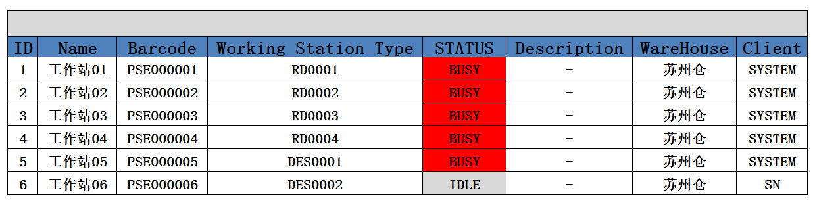

4、方法：

|  |
| --- |
| GET /System/ receivingStation |

1. 示例：

|  |
| --- |
| {  " receivingWorkingStation _search response ": {  " receivingWorkingStation _List": [  {  "id": " 903747BB-57CF-4272-8582-E30E61D67DBC",  "ClientId": {  "id": " 903747BB-57CF-4272-8582-E30E61D67DBC",  "name": "京东"  },  "WarehouseId": {  "id": " 903747BB-57CF-4272-8582-E30E61D67DBC",  "name": "苏州仓"  },  "Type": {  "id": " 903747BB-57CF-4272-8582-E30E61D67DBC",  "name": "Receiving Destination"  },  "name": " 工作站1 ",  "Description": " - ",  "  "VERSION" : 1,  "ENTITY_LOCK":"100",  “CREATED_BY”: {  “id”: “0123456789abcdef0123456789abcdef”,  “username”: “admin”  },  “MODIFIED_BY”: {  “id”: “0123456789abcdef0123456789abcdef”,  “username”: “admin”  },  “MODIFIED_DATE”: “2012-01-01T12:00:00Z”,  “MODIFIED_ DATE”: “2012-01-01T12:00:00Z”  }  ],  "total": 1,  }  } |

## Create

1、页面

1. 功能：创建一条Receiving Station记录

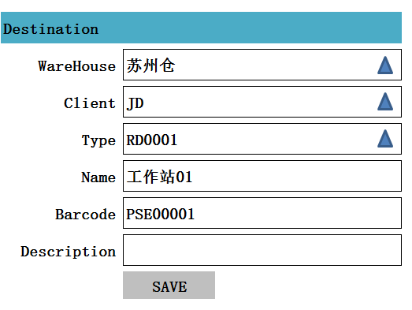

1. 方法：

|  |
| --- |
| POST /System/ ReceivingStation |

4、输入参数

|  |  |  |  |  |
| --- | --- | --- | --- | --- |
| **参数名称** | **类型** | **是否必须** | **示例值** | **描述** |
| WareHouse_ID | String | 是 | 苏州仓 | 仓库编码 |
| Client_ID | String | 是 | JD | 客户编码 |
| Type | String | 是 | RD0001 | Receiving Working Station Type记录 |
| Name | String | 是 | 工作站 | 名称 |
| Description | String | 否 | 描述信息 |  |

5、示例

|  |
| --- |
| {  "id": " 903747BB-57CF-4272-8582-E30E61D67DBC",  "ClientId": {  "id": " 903747BB-57CF-4272-8582-E30E61D67DBC",  "name": "京东"  },  "WarehouseId": {  "id": " 903747BB-57CF-4272-8582-E30E61D67DBC",  "name": "苏州仓"  },  "type": {  "id": " 903747BB-57CF-4272-8582-E30E61D67DBC",  "name": "RD001"  },  "name": " 工作站1",  "Description": " - ",  "VERSION" : 1,  "ENTITY_LOCK":"100",  “CREATED_BY”: {  “id”: “0123456789abcdef0123456789abcdef”,  “username”: “admin”  },  “MODIFIED_BY”: {  “id”: “0123456789abcdef0123456789abcdef”,  “username”: “admin”  },  “MODIFIED_DATE”: “2012-01-01T12:00:00Z”,  “MODIFIED_ DATE”: “2012-01-01T12:00:00Z”  } |

## Edit

1、页面

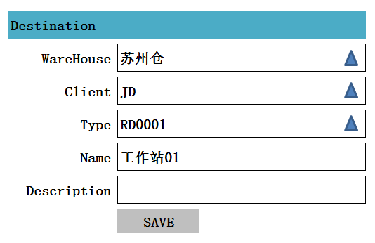

1. 功能：编辑一条Receiving Working Station记录
2. 方法：

|  |
| --- |
| PUT /System/ ReceivingWorkingStation/{id} |

4、输入参数

|  |  |  |  |  |
| --- | --- | --- | --- | --- |
| **参数名称** | **类型** | **是否必须** | **示例值** | **描述** |
| WareHouse_ID | String | 是 | 苏州仓 | 仓库编码 |
| Client_ID | String | 是 | JD | 客户编码 |
| Type | String | 是 | RD0001 | Receiving Working Station Type记录 |
| Name | String | 是 | 工作站 | 名称 |
| Description | String | 否 | 描述信息 |  |

5、示例

|  |
| --- |
| {  "id": " 903747BB-57CF-4272-8582-E30E61D67DBC",  "ClientId": {  "id": " 903747BB-57CF-4272-8582-E30E61D67DBC",  "name": "京东"  },  "WarehouseId": {  "id": " 903747BB-57CF-4272-8582-E30E61D67DBC",  "name": "苏州仓"  },  "type": {  "id": " 903747BB-57CF-4272-8582-E30E61D67DBC",  "name": "RD001"  },  "name": " 工作站1",  "Description": " - ",  "VERSION" : 1,  "ENTITY_LOCK":"100",  “CREATED_BY”: {  “id”: “0123456789abcdef0123456789abcdef”,  “username”: “admin”  },  “MODIFIED_BY”: {  “id”: “0123456789abcdef0123456789abcdef”,  “username”: “admin”  },  “MODIFIED_DATE”: “2012-01-01T12:00:00Z”,  “MODIFIED_ DATE”: “2012-01-01T12:00:00Z”  } |

## Detail

1、页面



2、功能：获得一条Receiving Working Station记录

3、方法：

|  |
| --- |
| GET /System/ ReceivingWorkingStation/{id} |

4、示例

|  |
| --- |
| {  "id": " 903747BB-57CF-4272-8582-E30E61D67DBC",  "ClientId": {  "id": " 903747BB-57CF-4272-8582-E30E61D67DBC",  "name": "京东"  },  "WarehouseId": {  "id": " 903747BB-57CF-4272-8582-E30E61D67DBC",  "name": "苏州仓"  },  "type": {  "id": " 903747BB-57CF-4272-8582-E30E61D67DBC",  "name": "RD001"  },  "name": " 工作站1",  "Description": " - ",  "VERSION" : 1,  "ENTITY_LOCK":"100",  “CREATED_BY”: {  “id”: “0123456789abcdef0123456789abcdef”,  “username”: “admin”  },  “MODIFIED_BY”: {  “id”: “0123456789abcdef0123456789abcdef”,  “username”: “admin”  },  “MODIFIED_DATE”: “2012-01-01T12:00:00Z”,  “MODIFIED_ DATE”: “2012-01-01T12:00:00Z”  } |

## Delete

1、功能：删除一条Receiving Working Station记录

2、方法：

|  |
| --- |
| GET /System/ ReceivingWorkingStation/{id} |

3、示例

|  |
| --- |
| {  "id": " 903747BB-57CF-4272-8582-E30E61D67DBC",  "ClientId": {  "id": " 903747BB-57CF-4272-8582-E30E61D67DBC",  "name": "京东"  },  "WarehouseId": {  "id": " 903747BB-57CF-4272-8582-E30E61D67DBC",  "name": "苏州仓"  },  "type": {  "id": " 903747BB-57CF-4272-8582-E30E61D67DBC",  "name": "RD001"  },  "name": " 工作站1",  "Description": " - ",  "VERSION" : 1,  "ENTITY_LOCK":"100",  “CREATED_BY”: {  “id”: “0123456789abcdef0123456789abcdef”,  “username”: “admin”  },  “MODIFIED_BY”: {  “id”: “0123456789abcdef0123456789abcdef”,  “username”: “admin”  },  “MODIFIED_DATE”: “2012-01-01T12:00:00Z”,  “MODIFIED_ DATE”: “2012-01-01T12:00:00Z”  } |

# SKUTYPEGRADESTATS

## List

1、显示所有SKUTYPEGRADESTATS记录

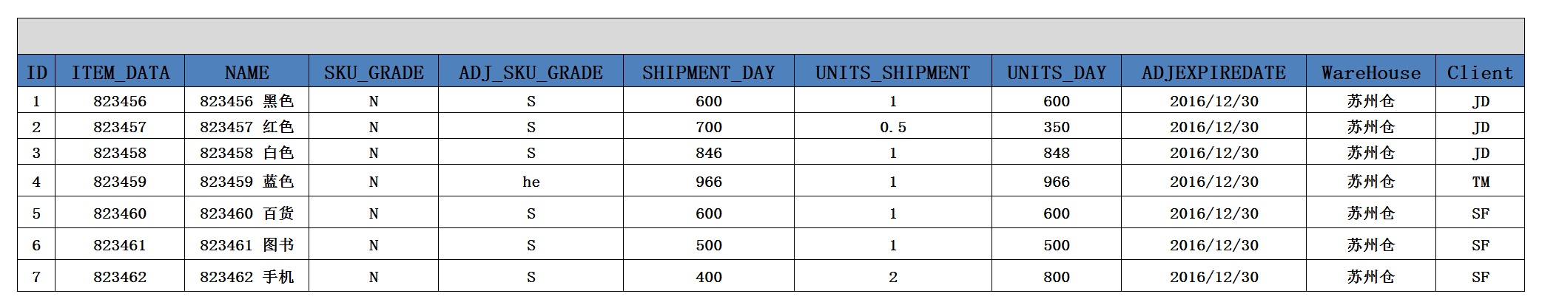

## Create

1、创建一条SKUTYPEGRADESTATS记录

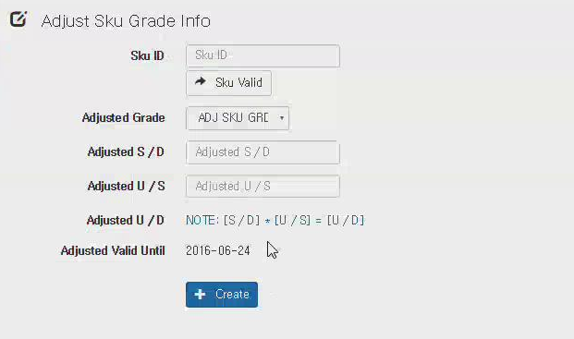

## Automatic【待定】

# STORAGESTRATEGY

## List

1、显示所有STORAGESTRATEGY记录

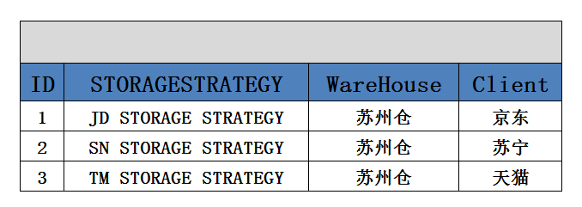

## Create

1、显示创建一条STORAGESTRATEGY记录页面

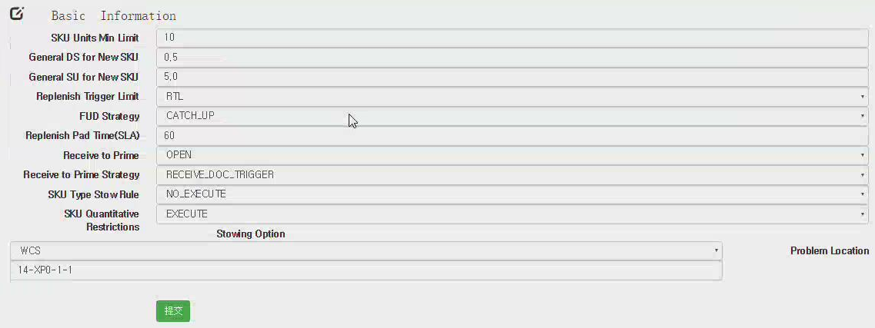

注释：

1、SKU UNITS MIN LIMIT 【SKU 最小执行单位】=10

2、GENERAL D/S FOR NEW SKU =0.5

3、GENERAL S/U FOR NEW SKU =5

以上3条表示：如果SKUTYPEGRADESTATS中没有相关SKU记录，参考1,2,3

4、REPIENISH TRIGGER LIMIT 【补充触发条件】【RLT/ZERO】

5、FUD STRAGEGY FUD策略【CATCH_UP / NOT_CATCH_UP】

REPIENISH PAD TIME(SLA) 【60】

RECEIVE TO PRIME 【OPEN/CLOSED】

RECEIVE TO PRIME STRATEGY 【RECEIVE_DOC_TRIGGER/SAFFTY_DOC_TRIGGER/】

SKU TYPE STOW RULE 【EXECUTE/NO_EXECUTE】

SKU QUANTITATIVE RESTRICTIONS 【EXECUTE/NO_EXECUTE】

STOWINS TYPE WCS

PROBLEM PROBLEM_LOCATION

PROBLEM_DESTINATION

# Rule Setting

## List

1、页面：显示列表

2、功能：显示所有的RECEIVINGCATEGORYRULE、RECEIVINGCATEGORYRULEPOSITION 数据

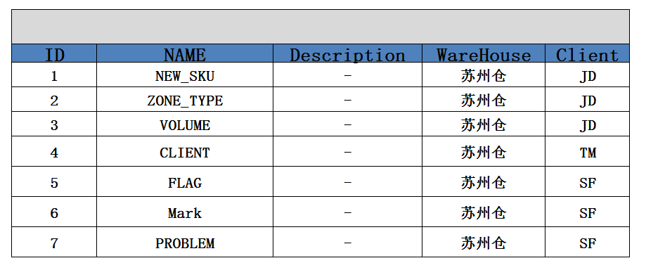

3、方法：

|  |
| --- |
| GET /System/ReceivingCategoryRule |

## Create

1、Create页面

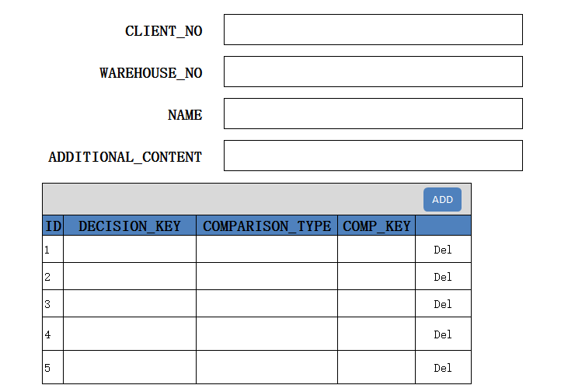

2、功能：创建一条ReceivingCategoryRule记录

3、方法：

|  |
| --- |
| POST /System/ ReceivingCategoryRule/{id} |

## Detail

1、Detail页面



2、方法：

|  |
| --- |
| GET /System/ReceivingCategoryRule/{id} |

## Edit

1、编辑一条RECEIVINGCATEGORYRULE记录



2、方法：

|  |
| --- |
| PUT /System/ ReceivingCategoryRule/{id} |

# Filter Basic Information

## List

1、页面初始化

2、功能：显示所有记录

参考：RECEIVINGCATEGORY、RECEIVINGCATEGORYPOSITION

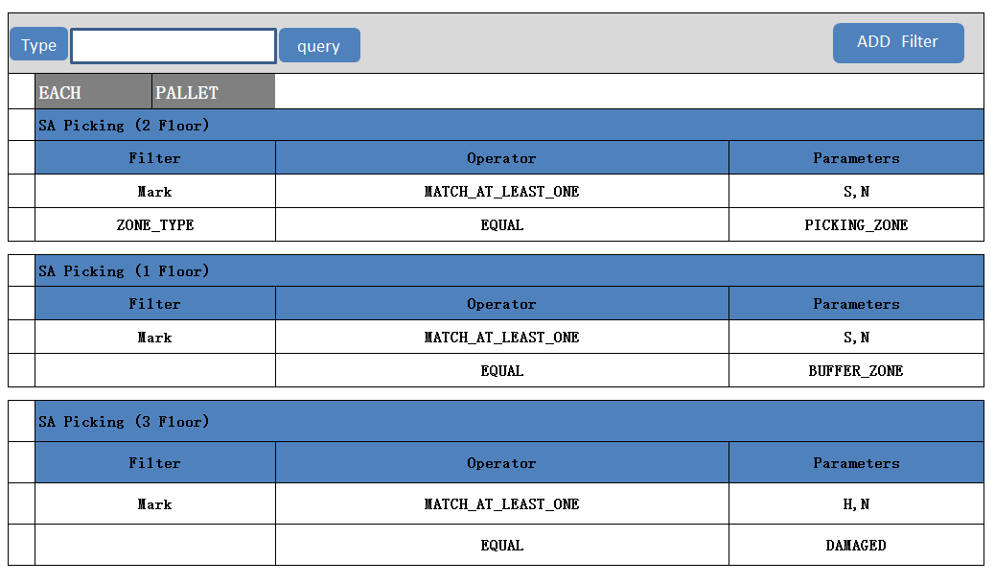

3、方法：

|  |
| --- |
| GET /System/ RECEIVINGCATEGORY_RECEIVINGCATEGORYPOSITION |

## Create

1. 页面
2. 功能：创建一条Filter

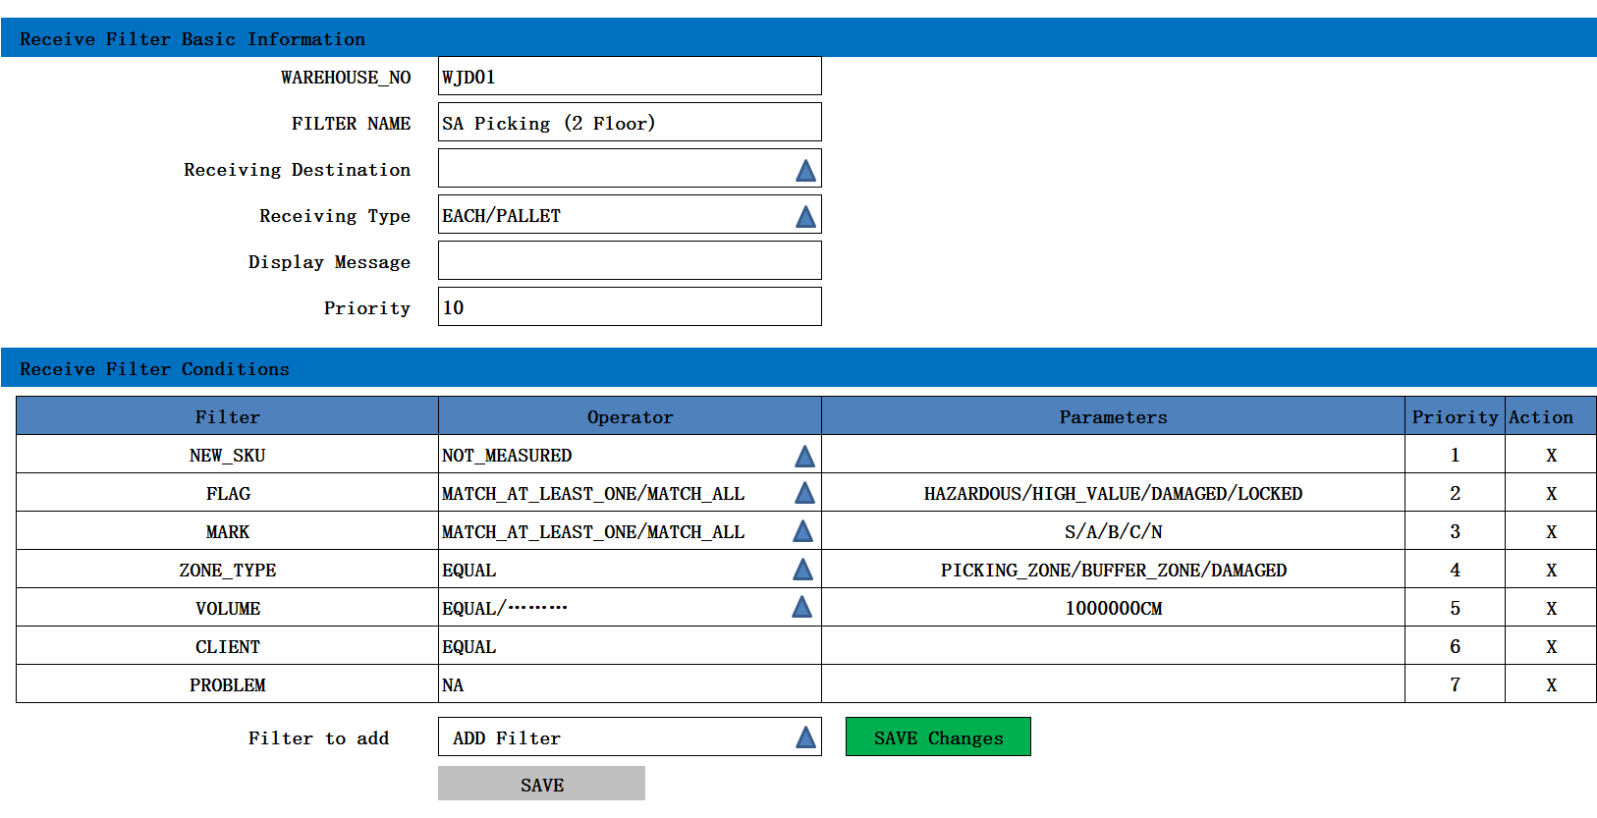

3、方法：

|  |
| --- |
| POST /System/ RECEIVINGCATEGORY_RECEIVINGCATEGORYPOSITION |

## Detail

1. Detail页面



## Edit

1. 页面

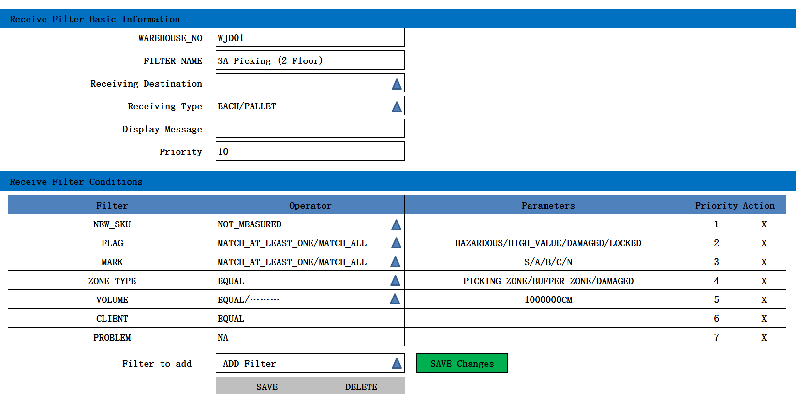

2、功能：编辑一条Filter

# Advice [DN]

## Advice List

注释：挂起、释放、打印

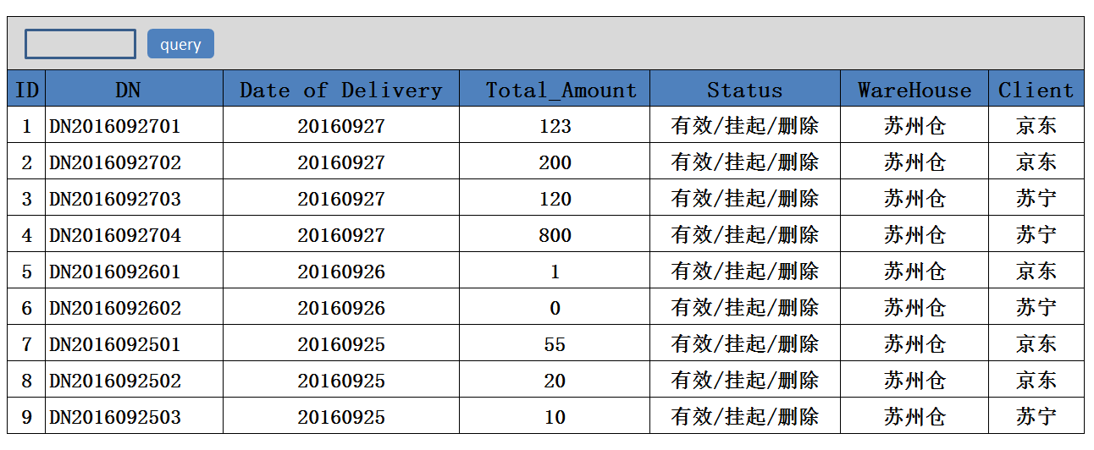

2、功能：获取所有有效的ADVICEREQUEST的DN记录

3、方法：

|  |
| --- |
| GET / Inbound /adviceRequest |

4、明细页面

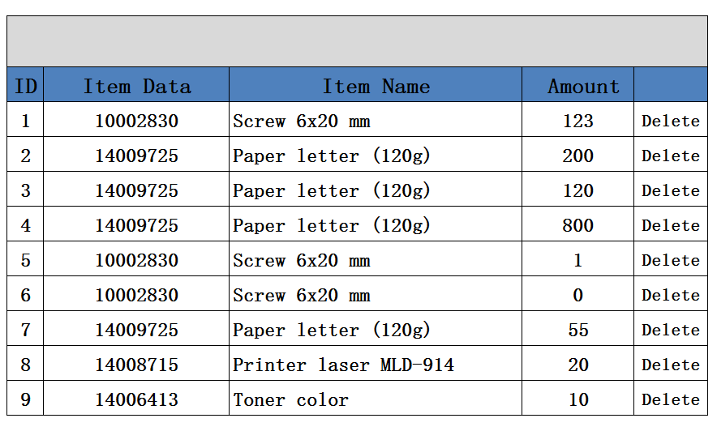

5、示例：

|  |
| --- |
| {  " adviceRequest_search response ": {  " adviceRequest_List": [  {  "ADVICE_NO": " DN2016092701",  "PROCESS_DATE ": 20160927,  "ITEMDATA_ID ": "10002830",  "RECEIPT_AMOUNT": "12",  "ADVICE_STATE":"1" ,  "ClientId": {  "id": " 903747BB-57CF-4272-8582-E30E61D67DBC",  "name": "京东"  },  "WarehouseId": {  "id": " 903747BB-57CF-4272-8582-E30E61D67DBC",  "name": "苏州仓"  }  }  ],  "total": 1,  }  } |

## Create

1、Create页面

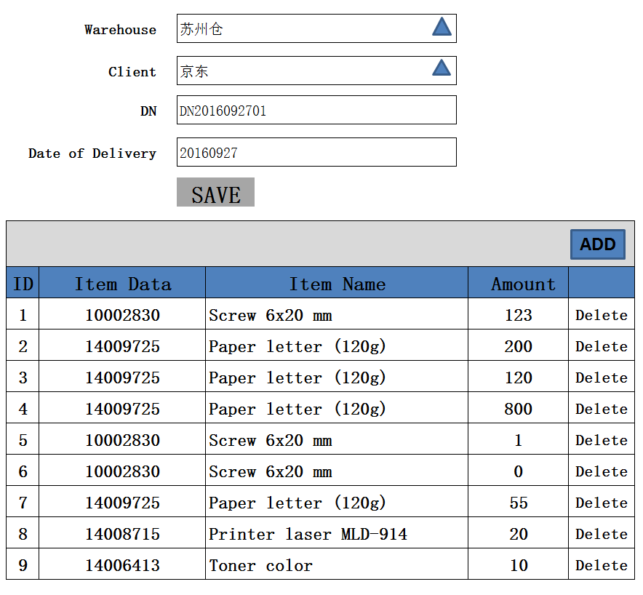

2、功能：新建一条DN SKU 记录

3、方法：

|  |
| --- |
| POST / Inbound /adviceRequest |

注释：Raw(0),Processing(100),GoodsToCome(200),Overdelivery(300),

Fulfilled(400),

4、输入参数

|  |  |  |  |  |
| --- | --- | --- | --- | --- |
| **参数名称** | **类型** | **是否必须** | **示例值** | **描述** |
| CLIENT_ID | String | 是 | 京东 | 客户名称 |
| WareHouse_ID | String | 是 | 仓库1 | 仓库名称 |
| DN | String | 是 | DN2016092701 | 【ADVICE_NO】 |
| Date of Delivery | String | 是 | 2016-09-29 | 预约时间【PROCESS_DATE】 |

5、点击“ADD”，子页面

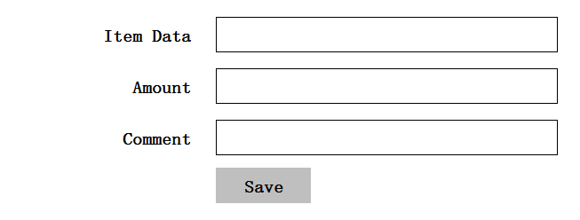

6、方法：

|  |
| --- |
| POST / Inbound /adviceRequestPosition |

7、输入参数

|  |  |  |  |  |
| --- | --- | --- | --- | --- |
| **参数名称** | **类型** | **是否必须** | **示例值** | **描述** |
| Item Data | String | 是 | 10002830 | SKU【 ITEMDATA_ID】 |
| Amount | String | 是 | 100 | 数量【NOTIFIED_AMOUNT】 |
| Comment | String | 否 | Other | 其它附加的信息 |

8、示例：

|  |
| --- |
| {  "id": “d75b38d24bd847789ee936af8db2873f”，  "client_id": {  “id”: “0123456789abcdef0123456789abcdef”,  “name”: “京东”  },  " WareHouse_id": {  “id”: “0123456789abcdef0123456789abcdef”,  “name”: “仓库1”  },  "ADVICE_NO": " DN2016092701",  "PROCESS_DATE ": 20160927,  "ITEMDATA_ID ": "10002830",  "RECEIPT_AMOUNT": "12",  "ADVICE_STATE":"1" ,  "VERSION" : 1,  "ENTITY_LOCK":"100" ,  “CREATED_BY”: {  “id”: “0123456789abcdef0123456789abcdef”,  “username”: “admin”  },  “MODIFIED_BY”: {  “id”: “0123456789abcdef0123456789abcdef”,  “username”: “admin”  },  “MODIFIED_DATE”: “2012-01-01T12:00:00Z”,  “MODIFIED_ DATE”: “2012-01-01T12:00:00Z”  } |

## Detail

1. 功能：获取一条adviceRequest记录
2. 方法：

|  |
| --- |
| GET / Inbound /adviceRequest/{id} |

1. 示例

|  |
| --- |
| {  "id": “d75b38d24bd847789ee936af8db2873f”，  "client_id": {  “id”: “0123456789abcdef0123456789abcdef”,  “name”: “京东”  },  " WareHouse_id": {  “id”: “0123456789abcdef0123456789abcdef”,  “name”: “仓库1”  },  "ADVICE_NO": " DN2016092701",  "PROCESS_DATE ": 20160927,  "ITEMDATA_ID ": "10002830",  "RECEIPT_AMOUNT": "12",  "ADVICE_STATE":"1" ,  "VERSION" : VERSION + 1,  "ENTITY_LOCK":"101" ,  “CREATED_BY”: {  “id”: “0123456789abcdef0123456789abcdef”,  “username”: “admin”  },  “MODIFIED_BY”: {  “id”: “0123456789abcdef0123456789abcdef”,  “username”: “admin”  },  “MODIFIED_DATE”: “2012-01-01T12:00:00Z”,  “MODIFIED_ DATE”: “2012-01-01T12:00:00Z”  } |

## Delete

1、功能：删除一条adviceRequest记录

2、方法：

|  |
| --- |
| DELETE / Inbound /adviceRequest/{id} |

3、示例

|  |
| --- |
| {  "id": “d75b38d24bd847789ee936af8db2873f”，  "client_id": {  “id”: “0123456789abcdef0123456789abcdef”,  “name”: “京东”  },  " WareHouse_id": {  “id”: “0123456789abcdef0123456789abcdef”,  “name”: “仓库1”  },  "ADVICE_NO": " DN2016092701",  "PROCESS_DATE ": 20160927,  "ITEMDATA_ID ": "10002830",  "RECEIPT_AMOUNT": "12",  "ADVICE_STATE":"1" ,  "VERSION" : VERSION + 1,  "ENTITY_LOCK":"101" ,  “CREATED_BY”: {  “id”: “0123456789abcdef0123456789abcdef”,  “username”: “admin”  },  “MODIFIED_BY”: {  “id”: “0123456789abcdef0123456789abcdef”,  “username”: “admin”  },  “MODIFIED_DATE”: “2012-01-01T12:00:00Z”,  “MODIFIED_ DATE”: “2012-01-01T12:00:00Z”  } |

# Goods Receipt

## List

1、list页面

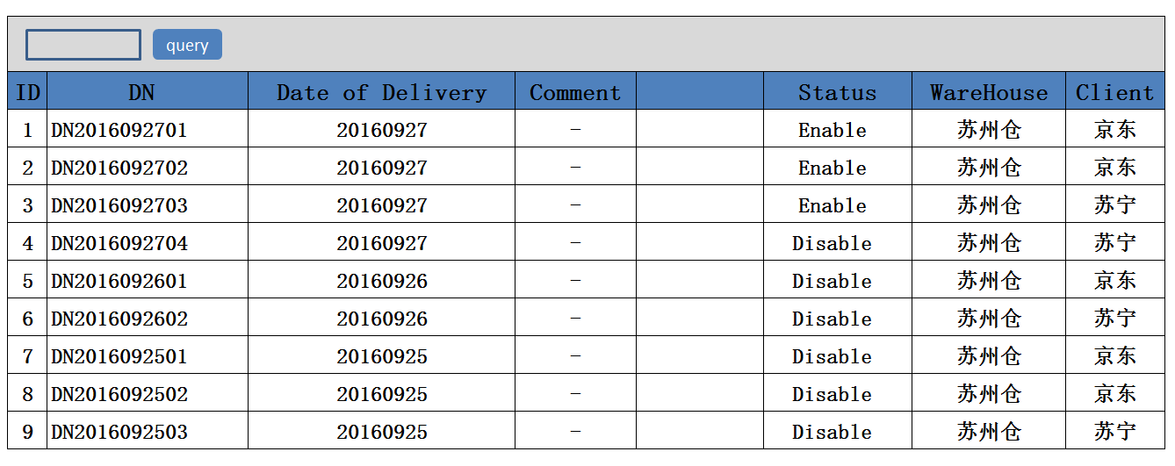

2、功能：获取所有Goods Receipt记录

3、方法：

|  |
| --- |
| GET / Inbound /Goods Receipt |

4、示例：

|  |
| --- |
| {  " adviceRequest_search response ": {  " adviceRequest_List": [  {  "Goods Receipt": " GR201609290001",  "Date of Receipt ": 20160929,  "DN ": " DN2016092701",  " STATUS ":"未处理" ,  "ClientId": {  "id": " 903747BB-57CF-4272-8582-E30E61D67DBC",  "name": "京东"  },  "WarehouseId": {  "id": " 903747BB-57CF-4272-8582-E30E61D67DBC",  "name": "苏州仓"  }  }  ],  "total": 1,  }  } |

## Activated

1、Goods Receipt激活页面

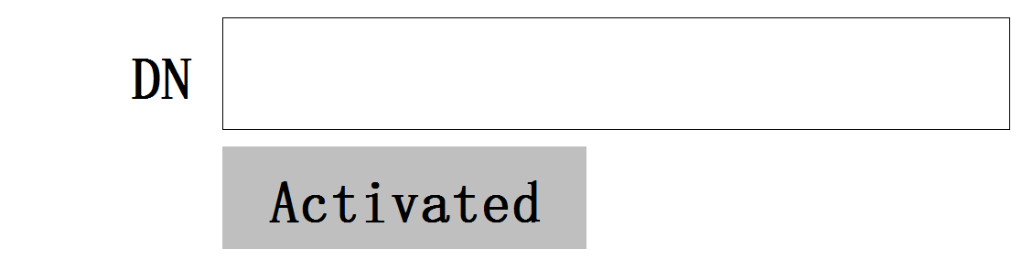

2、功能：根据DN创建一条Goods Receipt 记录

3、方法：

|  |
| --- |
| POST / Inbound /goodsReceipt/{DN_id} |

注释：Raw(0),Accepted(100),Finished(200),Canceled(300),Transfer(400)

1. 输入参数

|  |  |  |  |  |
| --- | --- | --- | --- | --- |
| Goods Receipt | | | | |
| **参数名称** | **类型** | **是否必须** | **示例值** | **描述** |
| CLIENT_ID | String | 是 | 京东 | 【GoodsReceipt】.【 CLIENT_ID】 |
| WareHouse_ID | String | 是 | 仓库1 | 【GoodsReceipt】.【 WareHouse_ID】 |
| Goods Receipt | String | 是 | GR201609290001 | 【GoodsReceipt】.【GR_NO】 |
| Date of Receipt | String | 是 | 20160929 | 【GoodsReceipt】.【RECEIPT_DATE】 |
| DN | String | 是 | DN2016092701 | 【GoodsReceipt】.【DELIVERY_NOTE】 |
| STATUS | String | 是 | 未处理 | 【GoodsReceipt】.【RECEIPT_STATE】 |

|  |  |  |  |  |
| --- | --- | --- | --- | --- |
| ~~Goods Receipt Position~~ | | | | |
| **~~参数名称~~** | **~~类型~~** | **~~是否必须~~** | **~~示例值~~** | **~~描述~~** |
| ~~Item data~~ | ~~String~~ | ~~是~~ | ~~10002830~~ | ~~【GoodsReceiptPosition】。【 Itemdata】~~ |
| ~~Remaining Amount~~ | ~~decimal~~ | ~~是~~ | ~~200~~ | ~~【GoodsReceiptPosition】。【AMOUNT】~~ |
| ~~Notified Amount~~ | ~~decimal~~ | ~~是~~ | ~~198~~ | ~~【GoodsReceiptPosition】。【SCALE】~~ |
| ~~Difference Value~~ | ~~decimal~~ | ~~是~~ | ~~2~~ | ~~差值= 【 Remaining Amount】-【 Notified Amount】~~ |

5、示例

## Detail

1、Detail页面

2、功能：查询一条Goods Receipt记录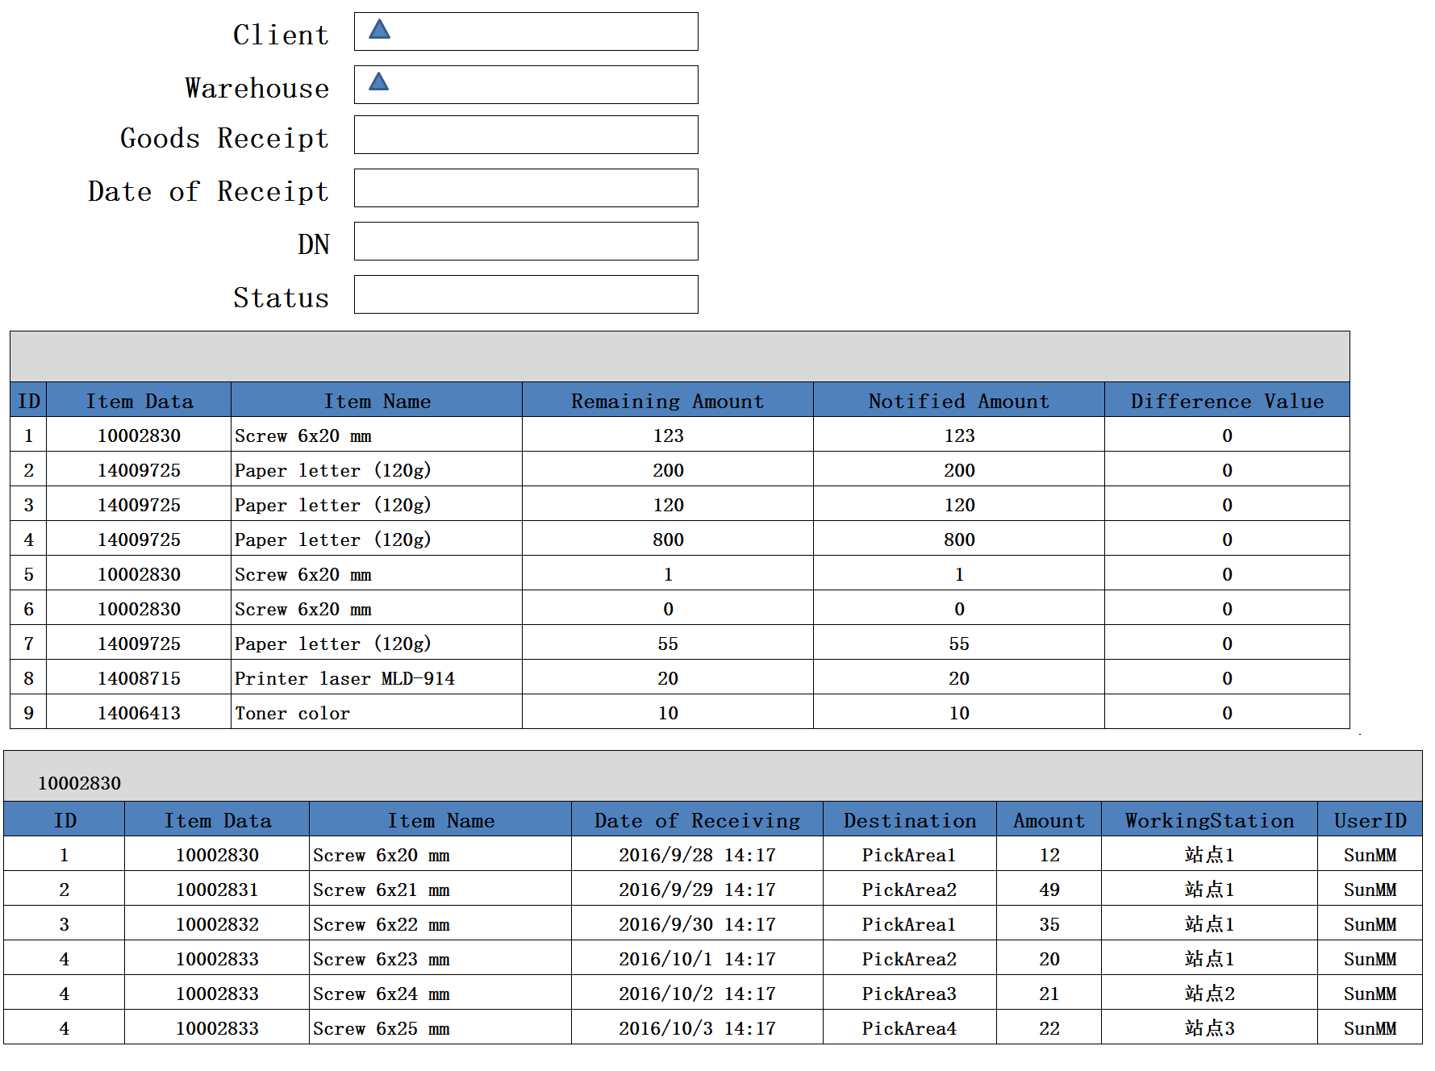

3、方法：

|  |
| --- |
| GET / Inbound /adviceRequest/{id} |

4、示例：

|  |
| --- |
| {  "Goods Receipt": " GR201609290001",  "Date of Receipt ": 20160929,  "DN ": " DN2016092701",  " STATUS ":"未处理" ,  "ClientId": {  "id": " 903747BB-57CF-4272-8582-E30E61D67DBC",  "name": "京东"  },  "WarehouseId": {  "id": " 903747BB-57CF-4272-8582-E30E61D67DBC",  "name": "苏州仓"  },  {  " GoodsReceiptPosition_List": [  {  " Item data ": " 10002830",  " Item name ": Screw 6x20 mm ,  " Remaining Amount ": 123,  " Notified Amount ": 123,  " Difference Value ": 0  } ,  {  " Item data ": " 14009725",  " Item name ": Paper letter (120g),  " Remaining Amount ": 200,  " Notified Amount ": 198,  " Difference Value ": 2  }  ],  "total": 2,  }  } |

# Receiving [Each]

## 主页面

1. 页面

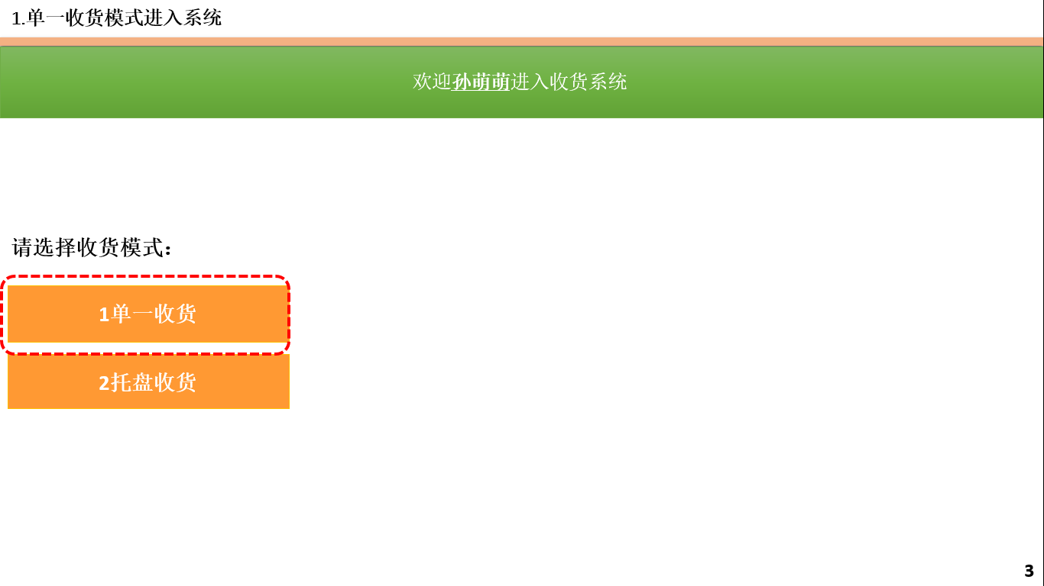

## Receiving准备

1. 页面

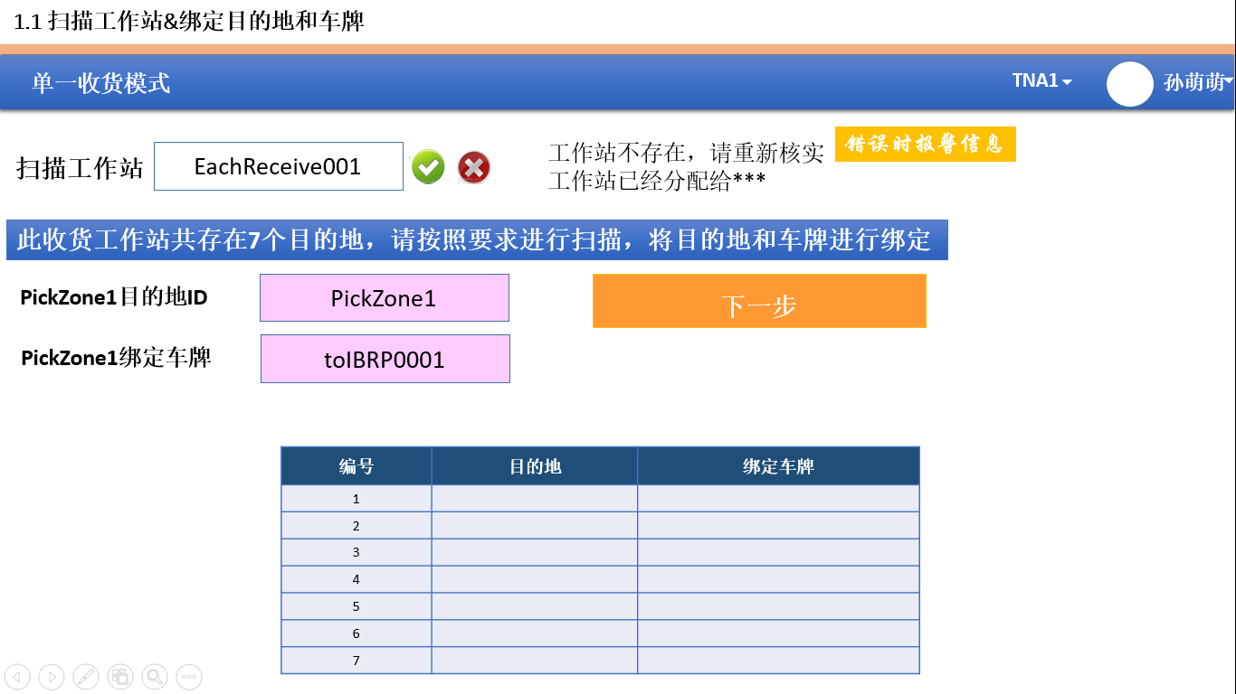

1. 扫描工作站,确认工作站状态是否正确，绑定工作站

-->Check工作站状态是否正确

|  |
| --- |
| Check / Inbound / ReceivingStationPosition /{ReceivinStation_id} |

1. 扫描目的地、扫描车牌

-->Check车牌状态是否正确

|  |
| --- |
| Check / Inbound / Container/{name} |

-->Check根据工作站的类型，检查是否所有的DESTINATION是否都绑定车牌

|  |
| --- |
| GET / Inbound /TypeDestinationConstraint/{ReceivingStationtype_id} |

1. 扫描Destination，扫描车辆，绑定Destination和车辆

注释： 1、检查Container的状态是否为可用状态

2、需要绑定所有的Destination，才能进入收货页面

|  |
| --- |
| PUT / Inbound / ReceivingStationPosition /{ ReceivingStation_id ,Container_id, ReceivingDestination_id } |

1. 输入参数

|  |  |  |  |  |
| --- | --- | --- | --- | --- |
| **参数名称** | **类型** | **是否必须** | **示例值** | **描述** |
| WareHouse_ID | String | 是 | 苏州仓 | 仓库编码 |
| Client_ID | String | 是 | JD | 客户编码 |
| ReceivingworkingStation_id | String | 是 | 工作站01 | Receiving Working Station 名称 |
| ReceivingDestination_id | String | 是 | RD0001 | ReceivingDestination名称 |
| Container_id | String | 否 | CON0001 | Container编号 |

1. 示例

|  |
| --- |
| {  "id": " 903747BB-57CF-4272-8582-E30E61D67DBC",  "ClientId": {  "id": " 903747BB-57CF-4272-8582-E30E61D67DBC",  "name": "京东"  },  "WarehouseId": {  "id": " 903747BB-57CF-4272-8582-E30E61D67DBC",  "name": "苏州仓"  },  "ReceivingworkingStation_id":"工作站01"，  "ReceivingDestination_id":" RD0001"，  "Container_id":" CON0001"，  "VERSION" : 1,  "ENTITY_LOCK":"100",  “CREATED_BY”: {  “id”: “0123456789abcdef0123456789abcdef”,  “username”: “admin”  },  “MODIFIED_BY”: {  “id”: “0123456789abcdef0123456789abcdef”,  “username”: “admin”  },  “MODIFIED_DATE”: “2012-01-01T12:00:00Z”,  “MODIFIED_ DATE”: “2012-01-01T12:00:00Z”  } |

## Receiving正常作业

1、页面

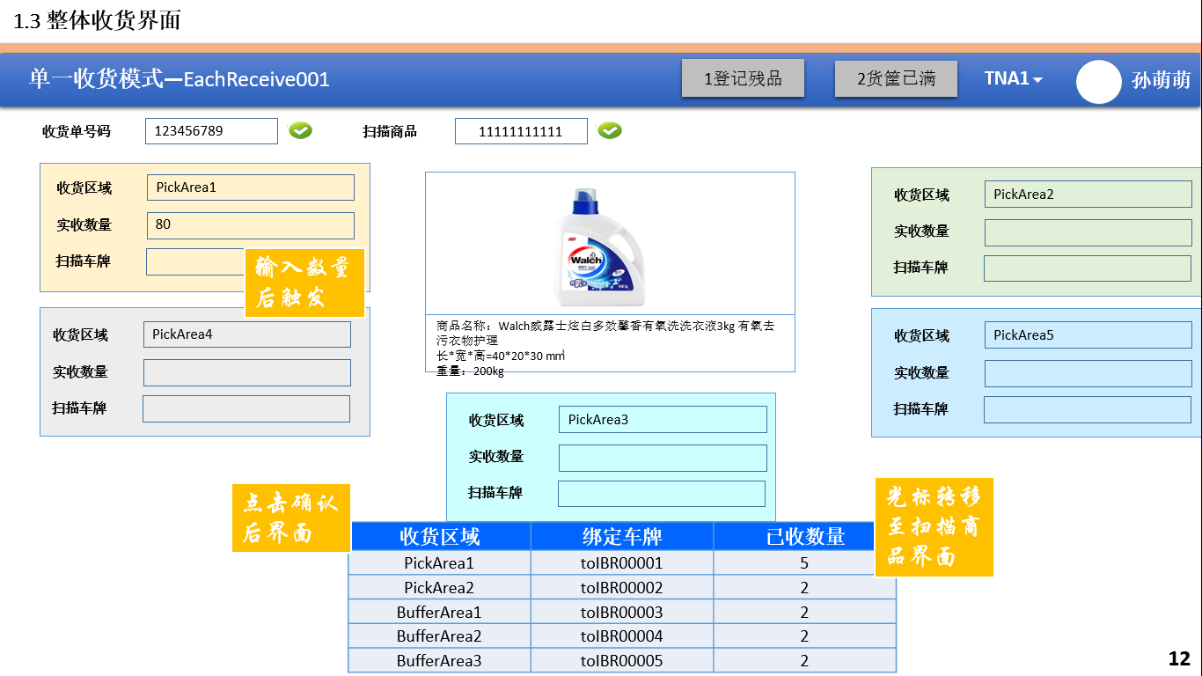

2、扫描DN，检测DN是否正确

|  |
| --- |
| Check / Inbound / goodsReceipt /{DELIVERY_NOTE} |

🡪DN Check条件：

a、收货单号码无效，请重新扫描

b、收货单号码RECEIPT_STATE=1已经被关闭，请重新扫描

c、收货单绑定客户和当前工作站绑定客户不符，请重新扫描

1. 扫描SKU，检查SKU是否正确

|  |
| --- |
| Check / Inbound / ADVICEREQUEST ,ADVICEREQUESTPOSITION/{SKU, ADVICE_NO} |

🡪SKU Check条件：

a、SKU商品条码无效，请扫描其他有效条码

b、sku+ ADVICE_NO商品不在此收货单内，请重新核实

c、SKU多货判断，检查DN中的SKU数量NOTIFIED_AMOUNT

d、如果ITEMDATA中SERIAL_RECORD_TYPE中，弹出输入SN页面

3、根据SKU获得需要指定的Destination

|  |
| --- |
| Get / Inbound / Receivingfilter /{SKU} |

🡪根据返回的Destination，显示指定的工位

|  |
| --- |
| GET / Inbound /TypeDestinationConstraint/{Destination_ID} |

4、扫描实际数量，输入数量检查是否正确

|  |
| --- |
| Check / Inbound / goodsReceiptPosition /{SKU, DN，Aoumt} |

🡪Check 车牌：根据返回的Destination，是否绑定

|  |
| --- |
| Get / Inbound / ReceivingStationPosition /{Destination} |

5、创建一条UnitLaod记录、UnitLaodRecord记录

|  |
| --- |
| POST /Inbound/UnitLaod |
| POST /Inbound/UnitLaodRecord |

6、扫描实际数量、扫描车辆，创建一条StockUnit记录

|  |
| --- |
| POST /Inbound/StockUnit |

7、输入参数

|  |  |  |  |  |
| --- | --- | --- | --- | --- |
| **参数名称** | **类型** | **是否必须** | **示例值** | **描述** |
| CLIENT_ID | String | 是 | 京东 | 客户名称 |
| WareHouse_ID | String | 是 | 仓库1 | 仓库名称 |
| Item Data | String | 是 | 10002830 | SKU【 ITEMDATA_ID】 |
| Amount | String | 是 | 100 | 数量【NOTIFIED_AMOUNT】 |
| Container | String | 是 | CON0001 | 容器 |

7、示例

|  |
| --- |
| {  "id": " 903747BB-57CF-4272-8582-E30E61D67DBC",  "ClientId": {  "id": " 903747BB-57CF-4272-8582-E30E61D67DBC",  "name": "京东"  },  "WarehouseId": {  "id": " 903747BB-57CF-4272-8582-E30E61D67DBC",  "name": "苏州仓"  },  "ReceivingworkingStation_id":"工作站01"，  "ReceivingDestination_id":" RD0001"，  "Container_id":" CON0001"，  "VERSION" : 1,  "ENTITY_LOCK":"100",  “CREATED_BY”: {  “id”: “0123456789abcdef0123456789abcdef”,  “username”: “admin”  },  “MODIFIED_BY”: {  “id”: “0123456789abcdef0123456789abcdef”,  “username”: “admin”  },  “MODIFIED_DATE”: “2012-01-01T12:00:00Z”,  “MODIFIED_ DATE”: “2012-01-01T12:00:00Z”  } |

8、记录一条GoodsReceiptPosition信息

|  |
| --- |
| POST /Inbound/GoodsReceiptPosition |

|  |  |  |  |  |
| --- | --- | --- | --- | --- |
| **参数名称** | **类型** | **是否必须** | **示例值** | **描述** |
| CLIENT_ID | String | 是 | 京东 | 客户名称 |
| WareHouse_ID | String | 是 | 仓库1 | 仓库名称 |
| Item Data | String | 是 | 10002830 | SKU【 ITEMDATA_ID】 |
| Amount | String | 是 | 100 | 数量【NOTIFIED_AMOUNT】 |
| GOODSRECEIPT_ID | String | 是 | G0000110 | 更加DN查询出 GOODSRECEIPT_ID |
| STOCKUNIT | String | 是 | S201610100001 | 上一条件记录的 STOCKUNIT ID |

## DN数量检查

SN检查

|  |
| --- |
| Check / Inbound / Goods Receipt/{SKU} |

🡪如果Goods Receipt Position中Aoumnt中的数量，是否超出规定数量

注释：[ADVICEREQUESTPOSITION]. [NOTIFIED_AMOUNT] – TOTEL ( [STORKUNIT]. [AMOUNT]) > [输入数量]

## SN检查

SN检查

|  |
| --- |
| Check / Inbound / ITEMDATA/{SKU} |

🡪如果ITEMDATA中SERIAL_RECORD_TYPE中，弹出输入SN页面

## 有效期检查

1、页面

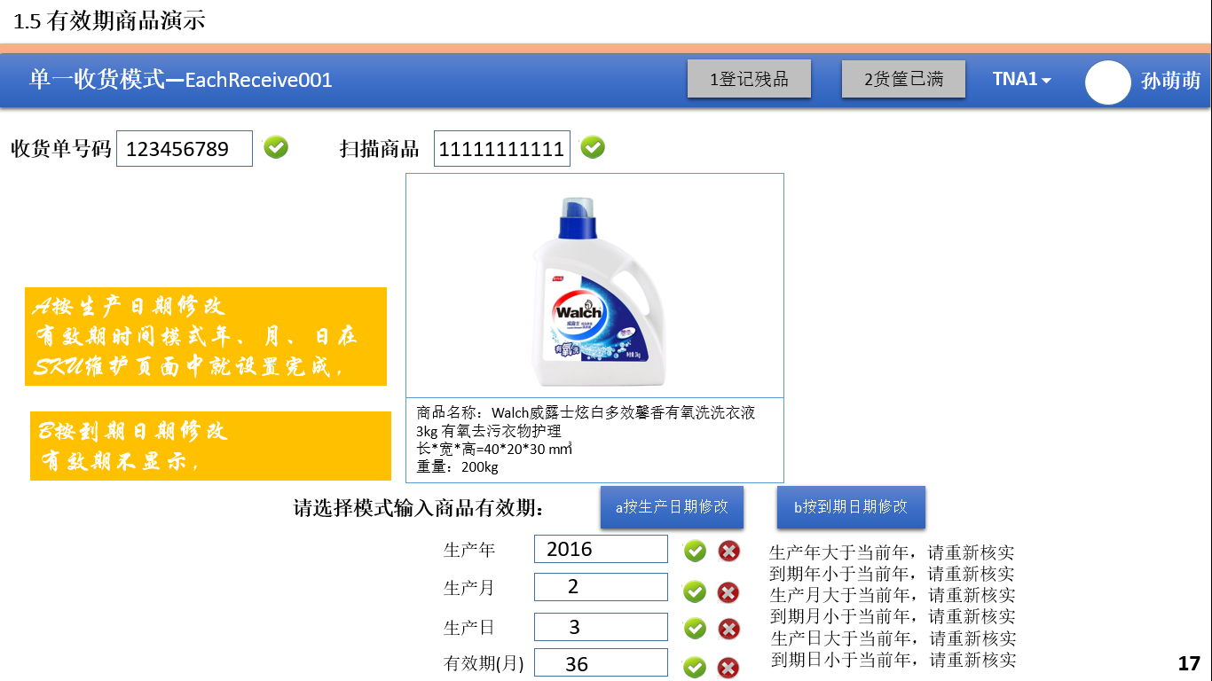

2、有效期检查

|  |
| --- |
| Check / Inbound / ITEMDATA/{SKU} |

🡪如果ITEMDATA中LOT_MANDATORY中，弹出有效检查页面

记录一条LOT记录

|  |
| --- |
| POST /Inbound/LOT |

5、创建一条UnitLaod记录、UnitLaodRecord记录

|  |
| --- |
| POST /Inbound/UnitLaod |
| POST /Inbound/UnitLaodRecord |

6、扫描实际数量、扫描车辆，创建一条StockUnit记录

|  |
| --- |
| POST /Inbound/StockUnit |

7、输入参数

|  |  |  |  |  |
| --- | --- | --- | --- | --- |
| **参数名称** | **类型** | **是否必须** | **示例值** | **描述** |
| CLIENT_ID | String | 是 | 京东 | 客户名称 |
| WareHouse_ID | String | 是 | 仓库1 | 仓库名称 |
| DN | String | 是 | DN2016092701 | 【ADVICE_NO】 |
| Item Data | String | 是 | 10002830 | SKU【 ITEMDATA_ID】 |
| Amount | String | 是 | 100 | 数量【NOTIFIED_AMOUNT】 |
| Destination | String | 是 | DES0001 | 目的区域 |
| Container | String | 是 | CON0001 | 容器 |
| STRATEGY_DATE | String | 是 | 2018-10-09 | 到期时间 |

8、示例

|  |
| --- |
| {  "id": " 903747BB-57CF-4272-8582-E30E61D67DBC",  "ClientId": {  "id": " 903747BB-57CF-4272-8582-E30E61D67DBC",  "name": "京东"  },  "WarehouseId": {  "id": " 903747BB-57CF-4272-8582-E30E61D67DBC",  "name": "苏州仓"  },  "ReceivingworkingStation_id":"工作站01"，  "ReceivingDestination_id":" RD0001"，  "Container_id":" CON0001"，  "VERSION" : 1,  "ENTITY_LOCK":"100",  “CREATED_BY”: {  “id”: “0123456789abcdef0123456789abcdef”,  “username”: “admin”  },  “MODIFIED_BY”: {  “id”: “0123456789abcdef0123456789abcdef”,  “username”: “admin”  },  “MODIFIED_DATE”: “2012-01-01T12:00:00Z”,  “MODIFIED_ DATE”: “2012-01-01T12:00:00Z”  } |

## 测量商品

1、页面

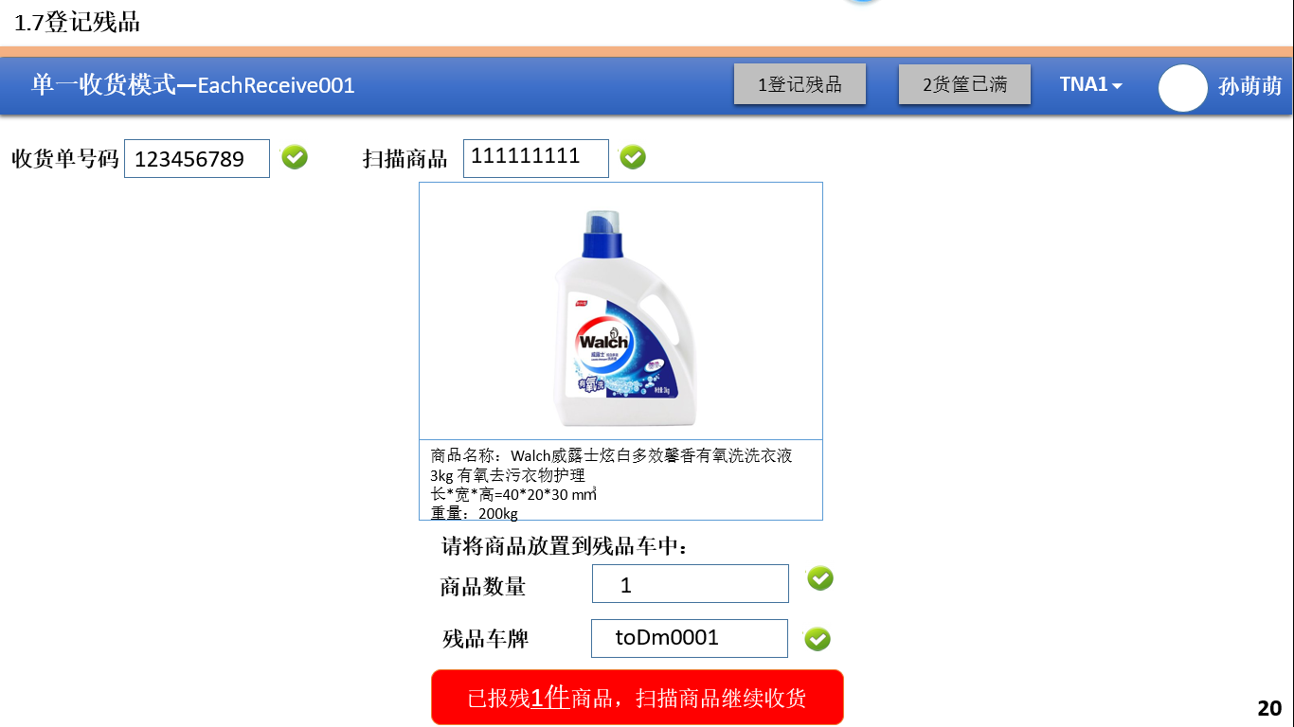

2、测量检查

|  |
| --- |
| Check / Inbound / itemsData /{SKU} |

🡪如果ITEMDATA中LOT_MEASURED=false中，弹出测量页面

->将LOT_MEASURED设为True，将物品放入残品车牌

|  |
| --- |
| Update / Inbound / itemsData /{SKU} |

3、创建一条UnitLaod记录、UnitLaodRecord记录

|  |
| --- |
| POST /Inbound/UnitLaod |
| POST /Inbound/UnitLaodRecord |

4、扫描实际数量、扫描车辆，创建一条StockUnit记录

|  |
| --- |
| POST /Inbound/StockUnit |

5、输入参数

|  |  |  |  |  |
| --- | --- | --- | --- | --- |
| **参数名称** | **类型** | **是否必须** | **示例值** | **描述** |
| CLIENT_ID | String | 是 | 京东 | 客户名称 |
| WareHouse_ID | String | 是 | 仓库1 | 仓库名称 |
| DN | String | 是 | DN2016092701 | 【ADVICE_NO】 |
| Item Data | String | 是 | 10002830 | SKU【 ITEMDATA_ID】 |
| Amount | String | 是 | 100 | 数量【NOTIFIED_AMOUNT】 |
| Destination | String | 是 | DES0001 | 目的区域 |
| Container | String | 是 | CON0001 | 容器 |

5、示例

|  |
| --- |
| {  "id": " 903747BB-57CF-4272-8582-E30E61D67DBC",  "ClientId": {  "id": " 903747BB-57CF-4272-8582-E30E61D67DBC",  "name": "京东"  },  "WarehouseId": {  "id": " 903747BB-57CF-4272-8582-E30E61D67DBC",  "name": "苏州仓"  },  "ReceivingworkingStation_id":"工作站01"，  "ReceivingDestination_id":" RD0001"，  "Container_id":" CON0001"，  "VERSION" : 1,  "ENTITY_LOCK":"100",  “CREATED_BY”: {  “id”: “0123456789abcdef0123456789abcdef”,  “username”: “admin”  },  “MODIFIED_BY”: {  “id”: “0123456789abcdef0123456789abcdef”,  “username”: “admin”  },  “MODIFIED_DATE”: “2012-01-01T12:00:00Z”,  “MODIFIED_ DATE”: “2012-01-01T12:00:00Z”  } |

## 登记残品

1、页面



2、点击“登记残品”按钮，进入页面

3、创建一条UnitLaod记录、UnitLaodRecord记录

|  |
| --- |
| POST /Inbound/UnitLaod |
| POST /Inbound/UnitLaodRecord |

4、扫描实际数量、扫描车辆，创建一条StockUnit记录

|  |
| --- |
| POST /Inbound/StockUnit |

4、输入参数

|  |  |  |  |  |
| --- | --- | --- | --- | --- |
| **参数名称** | **类型** | **是否必须** | **示例值** | **描述** |
| CLIENT_ID | String | 是 | 京东 | 客户名称 |
| WareHouse_ID | String | 是 | 仓库1 | 仓库名称 |
| DN | String | 是 | DN2016092701 | 【ADVICE_NO】 |
| Item Data | String | 是 | 10002830 | SKU【 ITEMDATA_ID】 |
| Amount | String | 是 | 100 | 数量【NOTIFIED_AMOUNT】 |
| Destination | String | 是 | DES0001 | 目的区域 |
| Container | String | 是 | CON0001 | 容器 |

5、示例

|  |
| --- |
| {  "id": " 903747BB-57CF-4272-8582-E30E61D67DBC",  "ClientId": {  "id": " 903747BB-57CF-4272-8582-E30E61D67DBC",  "name": "京东"  },  "WarehouseId": {  "id": " 903747BB-57CF-4272-8582-E30E61D67DBC",  "name": "苏州仓"  },  "ReceivingworkingStation_id":"工作站01"，  "ReceivingDestination_id":" RD0001"，  "Container_id":" CON0001"，  "VERSION" : 1,  "ENTITY_LOCK":"100",  “CREATED_BY”: {  “id”: “0123456789abcdef0123456789abcdef”,  “username”: “admin”  },  “MODIFIED_BY”: {  “id”: “0123456789abcdef0123456789abcdef”,  “username”: “admin”  },  “MODIFIED_DATE”: “2012-01-01T12:00:00Z”,  “MODIFIED_ DATE”: “2012-01-01T12:00:00Z”  } |

## 货款已满

1、页面

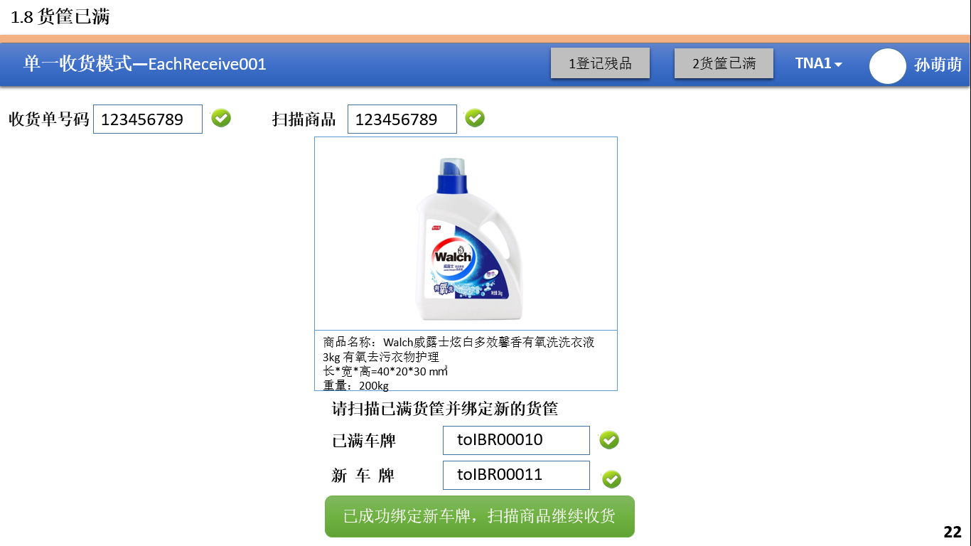

2、关闭已满车

|  |
| --- |
| DELETE / Inbound / ReceivingWorkingStationPosition /{ ReceivingworkingStation_id ,Container_id, ReceivingDestination_id } |

3、车辆设置为已满状态

|  |
| --- |
| PUT / Inbound / Container /{ id } |

4、绑定Destination和新的车辆

注释：需要绑定所有的Destination，才能进入收货页面

|  |
| --- |
| PUT / Inbound / ReceivingWorkingStationPosition /{ ReceivingworkingStation_id ,Container_id, ReceivingDestination_id } |

4、输入参数

|  |  |  |  |  |
| --- | --- | --- | --- | --- |
| **参数名称** | **类型** | **是否必须** | **示例值** | **描述** |
| WareHouse_ID | String | 是 | 苏州仓 | 仓库编码 |
| Client_ID | String | 是 | JD | 客户编码 |
| ReceivingworkingStation_id | String | 是 | 工作站01 | Receiving Working Station 名称 |
| ReceivingDestination_id | String | 是 | RD0001 | ReceivingDestination名称 |
| Container_id | String | 否 | CON0001 | Container编号 |

5、示例

|  |
| --- |
| {  "id": " 903747BB-57CF-4272-8582-E30E61D67DBC",  "ClientId": {  "id": " 903747BB-57CF-4272-8582-E30E61D67DBC",  "name": "京东"  },  "WarehouseId": {  "id": " 903747BB-57CF-4272-8582-E30E61D67DBC",  "name": "苏州仓"  },  "ReceivingworkingStation_id":"工作站01"，  "ReceivingDestination_id":" RD0001"，  "Container_id":" CON0001"，  "VERSION" : 1,  "ENTITY_LOCK":"100",  “CREATED_BY”: {  “id”: “0123456789abcdef0123456789abcdef”,  “username”: “admin”  },  “MODIFIED_BY”: {  “id”: “0123456789abcdef0123456789abcdef”,  “username”: “admin”  },  “MODIFIED_DATE”: “2012-01-01T12:00:00Z”,  “MODIFIED_ DATE”: “2012-01-01T12:00:00Z”  } |

# Receiving [Pallet]

## Receiving准备

参考【Receiving准备[Each]】

## Receiving作业【自动满框】

1. 页面

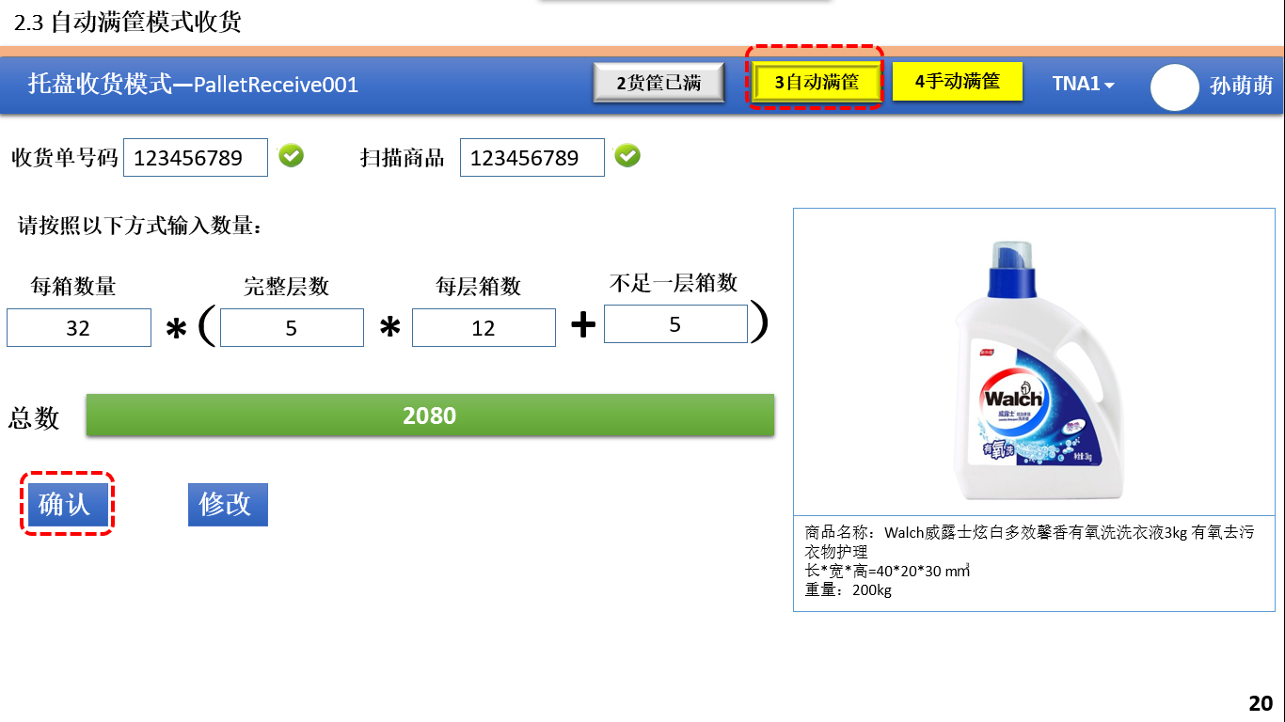

2、扫描DN，检测DN是否正确

|  |
| --- |
| Check / Inbound / goodsReceipt /{DN} |

1. 扫描SKU，检查SKU是否正确

|  |
| --- |
| Check / Inbound / goodsReceiptPosition /{SKU, DN} |

3、根据SKU获得需要指定的Destination

|  |
| --- |
| Get / Inbound / Receivingfilter /{SKU} |

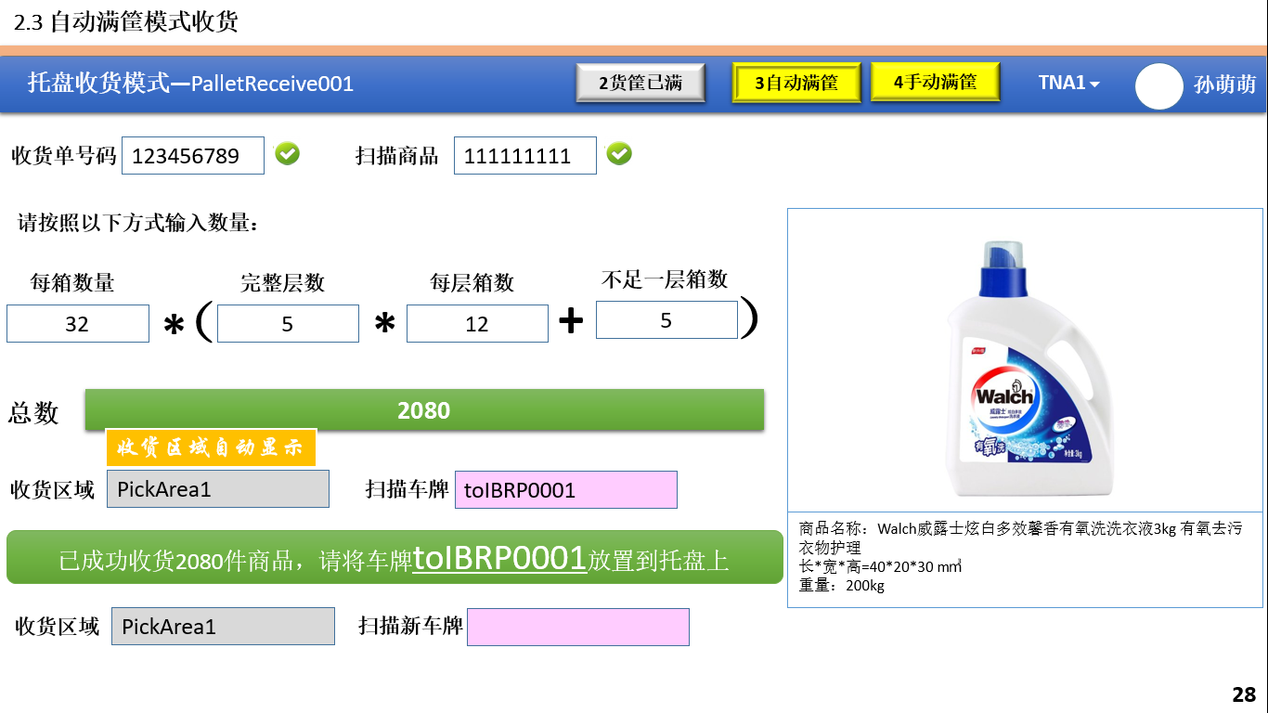

4、扫描实际数量，输入数量检查是否正确

|  |
| --- |
| Check / Inbound / goodsReceiptPosition /{SKU, DN，Aoumt} |

5、扫描实际数量、扫描车辆，创建一条StockUnit记录

|  |
| --- |
| POST /Inbound/StockUnit |

6、输入参数

|  |  |  |  |  |
| --- | --- | --- | --- | --- |
| **参数名称** | **类型** | **是否必须** | **示例值** | **描述** |
| CLIENT_ID | String | 是 | 京东 | 客户名称 |
| WareHouse_ID | String | 是 | 仓库1 | 仓库名称 |
| DN | String | 是 | DN2016092701 | 【ADVICE_NO】 |
| Item Data | String | 是 | 10002830 | SKU【 ITEMDATA_ID】 |
| Amount | String | 是 | 100 | 数量【NOTIFIED_AMOUNT】 |
| Destination | String | 是 | DES0001 | 目的区域 |
| Container | String | 是 | CON0001 | 容器 |

7、示例

|  |
| --- |
| {  "id": " 903747BB-57CF-4272-8582-E30E61D67DBC",  "ClientId": {  "id": " 903747BB-57CF-4272-8582-E30E61D67DBC",  "name": "京东"  },  "WarehouseId": {  "id": " 903747BB-57CF-4272-8582-E30E61D67DBC",  "name": "苏州仓"  },  "ReceivingworkingStation_id":"工作站01"，  "ReceivingDestination_id":" RD0001"，  "Container_id":" CON0001"，  "VERSION" : 1,  "ENTITY_LOCK":"100",  “CREATED_BY”: {  “id”: “0123456789abcdef0123456789abcdef”,  “username”: “admin”  },  “MODIFIED_BY”: {  “id”: “0123456789abcdef0123456789abcdef”,  “username”: “admin”  },  “MODIFIED_DATE”: “2012-01-01T12:00:00Z”,  “MODIFIED_ DATE”: “2012-01-01T12:00:00Z”  } |

8、更换车辆

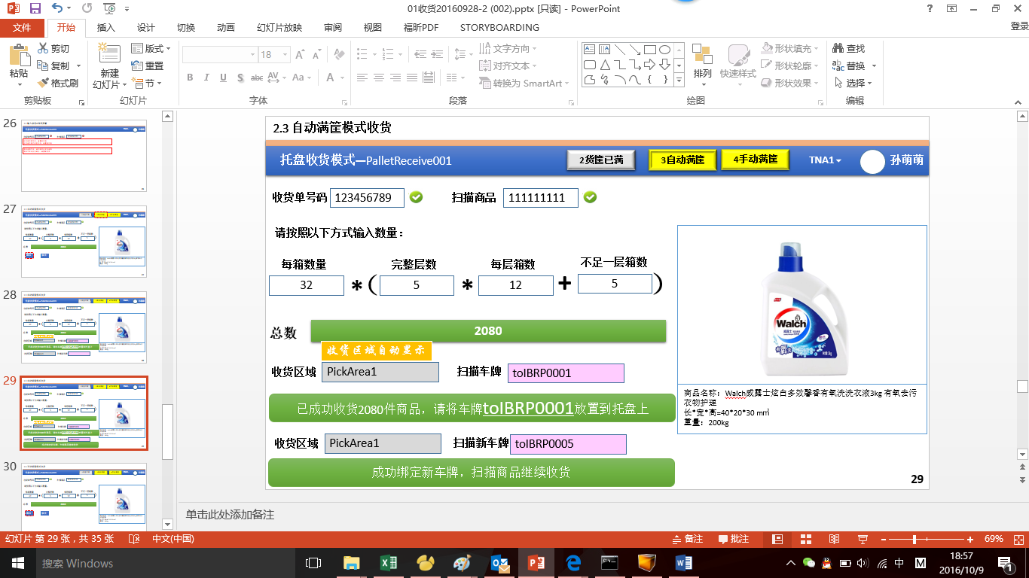

8.1、关闭已满车

|  |
| --- |
| DELETE / Inbound / ReceivingWorkingStationPosition /{ ReceivingworkingStation_id ,Container_id, ReceivingDestination_id } |

8.2、车辆设置为已满状态

|  |
| --- |
| PUT / Inbound / Container /{ id } |

8.2、绑定Destination和新的车辆

注释：需要绑定所有的Destination，才能进入收货页面

|  |
| --- |
| PUT / Inbound / ReceivingWorkingStationPosition /{ ReceivingworkingStation_id ,Container_id, ReceivingDestination_id } |

8.4、输入参数

|  |  |  |  |  |
| --- | --- | --- | --- | --- |
| **参数名称** | **类型** | **是否必须** | **示例值** | **描述** |
| WareHouse_ID | String | 是 | 苏州仓 | 仓库编码 |
| Client_ID | String | 是 | JD | 客户编码 |
| ReceivingworkingStation_id | String | 是 | 工作站01 | Receiving Working Station 名称 |
| ReceivingDestination_id | String | 是 | RD0001 | ReceivingDestination名称 |
| Container_id | String | 否 | CON0001 | Container编号 |

8.5、示例

|  |
| --- |
| {  "id": " 903747BB-57CF-4272-8582-E30E61D67DBC",  "ClientId": {  "id": " 903747BB-57CF-4272-8582-E30E61D67DBC",  "name": "京东"  },  "WarehouseId": {  "id": " 903747BB-57CF-4272-8582-E30E61D67DBC",  "name": "苏州仓"  },  "ReceivingworkingStation_id":"工作站01"，  "ReceivingDestination_id":" RD0001"，  "Container_id":" CON0001"，  "VERSION" : 1,  "ENTITY_LOCK":"100",  “CREATED_BY”: {  “id”: “0123456789abcdef0123456789abcdef”,  “username”: “admin”  },  “MODIFIED_BY”: {  “id”: “0123456789abcdef0123456789abcdef”,  “username”: “admin”  },  “MODIFIED_DATE”: “2012-01-01T12:00:00Z”,  “MODIFIED_ DATE”: “2012-01-01T12:00:00Z”  } |

## Receiving作业【手动满框页面】

1、页面

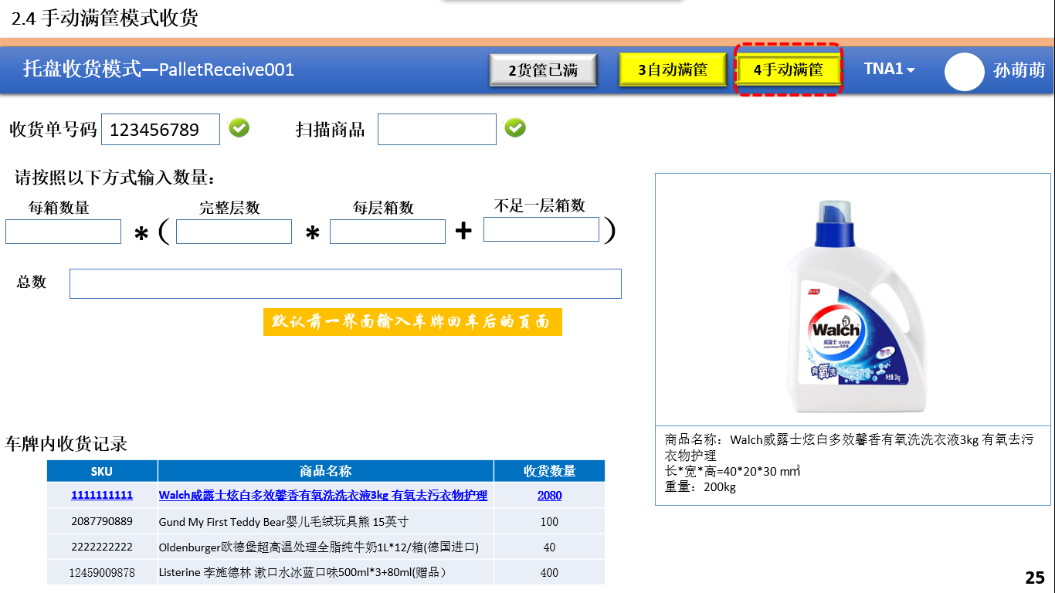

2、扫描实际数量，输入数量检查是否正确

|  |
| --- |
| Check / Inbound / goodsReceiptPosition /{SKU, DN，Aoumt} |

3、扫描实际数量、扫描车辆，创建一条StockUnit记录

|  |
| --- |
| POST /Inbound/StockUnit |

4、输入参数

|  |  |  |  |  |
| --- | --- | --- | --- | --- |
| **参数名称** | **类型** | **是否必须** | **示例值** | **描述** |
| CLIENT_ID | String | 是 | 京东 | 客户名称 |
| WareHouse_ID | String | 是 | 仓库1 | 仓库名称 |
| DN | String | 是 | DN2016092701 | 【ADVICE_NO】 |
| Item Data | String | 是 | 10002830 | SKU【 ITEMDATA_ID】 |
| Amount | String | 是 | 100 | 数量【NOTIFIED_AMOUNT】 |
| Destination | String | 是 | DES0001 | 目的区域 |
| Container | String | 是 | CON0001 | 容器 |

5、示例

|  |
| --- |
| {  "id": " 903747BB-57CF-4272-8582-E30E61D67DBC",  "ClientId": {  "id": " 903747BB-57CF-4272-8582-E30E61D67DBC",  "name": "京东"  },  "WarehouseId": {  "id": " 903747BB-57CF-4272-8582-E30E61D67DBC",  "name": "苏州仓"  },  "ReceivingworkingStation_id":"工作站01"，  "ReceivingDestination_id":" RD0001"，  "Container_id":" CON0001"，  "VERSION" : 1,  "ENTITY_LOCK":"100",  “CREATED_BY”: {  “id”: “0123456789abcdef0123456789abcdef”,  “username”: “admin”  },  “MODIFIED_BY”: {  “id”: “0123456789abcdef0123456789abcdef”,  “username”: “admin”  },  “MODIFIED_DATE”: “2012-01-01T12:00:00Z”,  “MODIFIED_ DATE”: “2012-01-01T12:00:00Z”  } |

## Receiving作业【货框已满】

1、页面

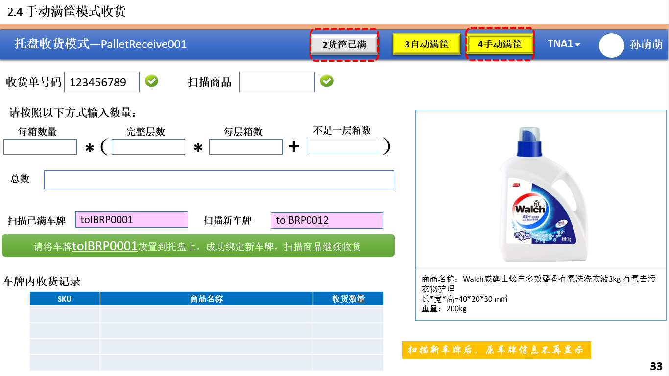

2、关闭已满车

|  |
| --- |
| DELETE / Inbound / ReceivingWorkingStationPosition /{ ReceivingworkingStation_id ,Container_id, ReceivingDestination_id } |

3、车辆设置为已满状态

|  |
| --- |
| PUT / Inbound / Container /{ id } |

4、绑定Destination和新的车辆

注释：需要绑定所有的Destination，才能进入收货页面

|  |
| --- |
| PUT / Inbound / ReceivingWorkingStationPosition /{ ReceivingworkingStation_id ,Container_id, ReceivingDestination_id } |

5、输入参数

|  |  |  |  |  |
| --- | --- | --- | --- | --- |
| **参数名称** | **类型** | **是否必须** | **示例值** | **描述** |
| WareHouse_ID | String | 是 | 苏州仓 | 仓库编码 |
| Client_ID | String | 是 | JD | 客户编码 |
| ReceivingworkingStation_id | String | 是 | 工作站01 | Receiving Working Station 名称 |
| ReceivingDestination_id | String | 是 | RD0001 | ReceivingDestination名称 |
| Container_id | String | 否 | CON0001 | Container编号 |

6、示例

|  |
| --- |
| {  "id": " 903747BB-57CF-4272-8582-E30E61D67DBC",  "ClientId": {  "id": " 903747BB-57CF-4272-8582-E30E61D67DBC",  "name": "京东"  },  "WarehouseId": {  "id": " 903747BB-57CF-4272-8582-E30E61D67DBC",  "name": "苏州仓"  },  "ReceivingworkingStation_id":"工作站01"，  "ReceivingDestination_id":" RD0001"，  "Container_id":" CON0001"，  "VERSION" : 1,  "ENTITY_LOCK":"100",  “CREATED_BY”: {  “id”: “0123456789abcdef0123456789abcdef”,  “username”: “admin”  },  “MODIFIED_BY”: {  “id”: “0123456789abcdef0123456789abcdef”,  “username”: “admin”  },  “MODIFIED_DATE”: “2012-01-01T12:00:00Z”,  “MODIFIED_ DATE”: “2012-01-01T12:00:00Z”  } |

# Stow Operation[上架]

## 上架作业步骤

1. 扫描Container ，获得Container中所有的记录

|  |
| --- |
| Get / Inbound / StockUnit /{Container_ID} |

## 单件上架

1、扫描SKU，获的单件记录

|  |
| --- |
| Get / Inbound / StockUnit /{Container_ID,SKU} |

2、插入一条StockUnit记录

|  |
| --- |
| POST /Inbound/StockUnit |

🡪 输入参数

|  |  |  |  |  |
| --- | --- | --- | --- | --- |
| **参数名称** | **类型** | **是否必须** | **示例值** | **描述** |
| CLIENT_ID | String | 是 | 京东 | 客户名称 |
| WareHouse_ID | String | 是 | 仓库1 | 仓库名称 |
| Item Data | String | 是 | 10002830 | SKU【 ITEMDATA_ID】 |
| Amount | String | 是 | 100 | 数量【NOTIFIED_AMOUNT】 |
| Container_ID | String | 是 | CON0001 | 容器 |
| Storage Location _ID | String | 是 | P-1-A332B432 | 库位 |

3、插入一条StockUnitRecord记录

|  |
| --- |
| POST /Inbound/StockUnitRecord |

4、减去一条StockUnit记录

|  |
| --- |
| POST /Inbound/StockUnit |

注：1、根据Container和SKU查询唯一值

5、检查Location与SKU是否匹配

|  |
| --- |
| Get / Inbound / StockLocation / {Location,SKU} |

## 批量上架

1、扫描SKU，获的单件记录

|  |
| --- |
| Get / Inbound / StockUnit /{Container_ID,SKU} |

2、插入一条StockUnit记录

|  |
| --- |
| POST /Inbound/StockUnit |

🡪 输入参数

|  |  |  |  |  |
| --- | --- | --- | --- | --- |
| **参数名称** | **类型** | **是否必须** | **示例值** | **描述** |
| CLIENT_ID | String | 是 | 京东 | 客户名称 |
| WareHouse_ID | String | 是 | 仓库1 | 仓库名称 |
| Item Data | String | 是 | 10002830 | SKU【 ITEMDATA_ID】 |
| Amount | String | 是 | 100 | 数量【NOTIFIED_AMOUNT】 |
| Container_ID | String | 是 | CON0001 | 容器 |
| Storage Location _ID | String | 是 | P-1-A332B432 | 库位 |

3、插入一条StockUnitRecord记录

|  |
| --- |
| POST /Inbound/StockUnitRecord |

4、减去一条StockUnit记录

|  |
| --- |
| POST /Inbound/StockUnit |

注：1、根据Container和SKU查询唯一值

## 残品处理

注释：暂时无法区分残品，只能根据【虚拟容器】查询

1、扫描SKU，获的单件记录

|  |
| --- |
| Get / Inbound / StockUnit /{Container_ID,SKU} |

2、插入一条StockUnit记录

|  |
| --- |
| POST /Inbound/StockUnit |

🡪 输入参数

|  |  |  |  |  |
| --- | --- | --- | --- | --- |
| **参数名称** | **类型** | **是否必须** | **示例值** | **描述** |
| CLIENT_ID | String | 是 | 京东 | 客户名称 |
| WareHouse_ID | String | 是 | 仓库1 | 仓库名称 |
| Item Data | String | 是 | 10002830 | SKU【 ITEMDATA_ID】 |
| Amount | String | 是 | 100 | 数量【NOTIFIED_AMOUNT】 |
| Container_ID | String | 是 | CON0001 | 容器 |
| Storage Location _ID | String | 是 | P-1-A332B432 | 库位【虚拟容器】 |

3、插入一条StockUnitRecord记录

|  |
| --- |
| POST /Inbound/StockUnitRecord |

4、减去一条StockUnit记录

|  |
| --- |
| POST /Inbound/StockUnit |

注：1、根据Container和SKU查询唯一值

## 多货处理

1、SKU不存在

|  |
| --- |
| Check /Inbound/StockUnit/{Container,SKU} |

2、多货

|  |
| --- |
| Check /Inbound/StockUnit/{Container,SKU} |

## 信息查询

1、获得相关信息

|  |
| --- |
| GET /Inbound/StockUnit/{container} |

## 报告暗灯【暂定】

## 结束上架

1、完全结束

注：关闭container，状态调整为可用状态

|  |
| --- |
| POST /Inbound/container/{id} |

2、少货